**A Quantitative Study Describing the Impact of Innovation-related Investment and Management Performance on Corporate Financial Returns**

**Student’s Name:**

**Student’s ID:**

**Acknowledgement**

I want to acknowledge all the people who have helped me in the research. I am thankful to my supervision __________ without whose help the dissertation would not be completed. I am also thankful to my friends, family and peer group whose blessing has helped me motivate my spirit and complete this dissertation.

Thanking you all,

______________

**Abstract**

Nowadays innovation is one of the parts of the organisation and now most organisations try to invest in the innovation of the company. In this way, it has been found that investment in innovation is working as an effective advantage for the organisation and also the direct expenditure can be capable of providing appropriate services to the company. The overall Innovation and the research process are used to store the study on the description of the impact of innovation investment and management performance on the Corporate financial return. In this way, the overall discussion has been discussed by using the different chapters that include the step-by-step process and also properly analysing the topic. The data gathering technique and methods are also used by the researchers in this overall study which provides appropriate knowledge about the overall topic and also provides future recommendations for the researchers. There is also a discussion that has been conducted on the limitations of the study which need to be fully filled by the researchers in further studies.

**Table of Contents**

Chapter 1: Introduction **7**

1.1 Background 7

1.2 Problem Statement 8

1.3 Research Aim 9

1.4 Research Objectives 9

1.5 Research Question 9

1.6 Research Rationale 10

1.7 Research Structure 10

Chapter 2: Literature Review **12**

2.1 Introduction 12

2.2 Concept of innovation related investment 12

2.3 Impact of innovation-related investment on management performance 14

2.4 Define the relationship between innovative investment on management performance 15

2.5 Challenges of innovation related investment on management performance 17

2.6 Theories and models 17

2.7 Issues regarding corporate financial returns on management performance 19

2.8 Strategies to mitigate the challenges 21

2.9 Summary 23

Chapter 3: Methodology **25**

3.1 Introduction 25

3.2 Research Method Proposition 25

3.3 Research Onion 26

3.4 Research Philosophy 27

3.5 Research design 28

3.6 Research Approach 28

3.7 Research Strategy 29

3.8 Time-Horizon 29

3.9 Data Source 30

3.10 Sample Size and Sampling Method 30

3.11 Data Collection Method 30

3.12 Data Analysis Technique 31

3.13 Ethical Considerations 31

3.14 Time Plan 32

3.15 Summary 32

**Chapter 4: Findings, Analysis, and Discussion** **34**

4.1 Introduction 34

4.2 Primary Analysis 34

4.2.1 Age 34

4.2.2 Gender 35

4.2.3 Department of Working 36

4.2.4 Experience 37

4.2.5 Correlation between innovation and financial returns 39

4.2.6 Rationale behind investment for innovation 40

4.2.7 Innovation-based investment and Management Performance 41

4.2.8 Innovation and long-term financial returns 42

4.2.9 Shortage of liquid funds due to innovation-related investment 43

4.2.10 Negative financial impact due to innovation-related investment 44

4.2.11 Negative impact on employee motivation 45

4.2.12 Market scanning before investment 46

4.2.13 Need of liquid fund reserve 47

4.3 Discussion 48

4.4 Summary 55

Chapter 5: Conclusion and Recommendations **56**

5.1 Conclusion 56

5.2 Linking with objectives 56

5.3 Recommendations 57

5.4 Limitations of the study 57

5.5 Future scope of the research 58

Reference List **60**

Appendix **68**

Appendix 1: Survey Questionnaire 68

# Chapter 1: Introduction

## Background

The innovation-related investments can be calculated by inducting the comparison of profits and different kinds of new products and service sales of the research work. There can be different types of direct expenditures that are being generated to create new products and services. There is a need for return on innovation investments and innovation investment can help in understanding the same. Management practices are an internal matter of an organisation and it is often found that without proper innovation-related investment, the efficient management practice got depreciated (Vinci *et al.,* 2019).

As opined by Yang, Nahm and Song (2022), it is found that focusing on innovation investment is mostly about learning how well an organisation is utilising its fund in order to innovate new products or services. However, from the research of Bammens, Hünermund and Andries (2022), it can be stated that a successful analysis of innovation investment can add additional profit to the organisation with the proper understanding of spending in the research and development segment. It can be stated that innovation-investment is having a huge influence on management decisions and it would help the company to forecast demands on the latest offerings. This also provides a detailed presumption on the efficiency of resource allocation and based on that further decisions regarding the business are made by the official management team. The ability to make the decision empowers the management team to get a better investment return and thus the revenue-earning is generated and the overall performance of the organisation is better (Vinci *et al.,* 2019). Hence, to gain a long-term outcome from the business performance, an organisation needs proper planning regarding innovation investment.

This present research work, it should be done with utmost care and diligence as the investment subject is crucial to make investment decisions. The result of the prudent decision can bring the best outcome in order to contribute to the long-term performance of the organisation. In this particular chapter, the overview or background of the same would be discussed along with the finding of the research aim. It can be stated that the research aim is helping to guide the research work in a competent manner and helps to find out the objectives of the chosen research topic. As this present chapter was identifying the research aim and research objectives were obtained from the research aim, this chapter identified the research objectives as well. Classification of research questions in the current research context was imperative and this chapter clarified the same. Stating the basic problem behind the conduction of this study was essential and a problem statement was provided. On the other hand, the research work was intended to show the significance of the present study and hence, this chapter has elaborated on the same in a systematic manner. Similarly, as it is quantitative research work, the implementation of research hypotheses was essential and this chapter has also provided the same. Finally based on the subject and the objectives of the current research work, a research structure is going to be prepared.

## Problem Statement

The research of Benetyte, Gonenc and Krusinskas (2021), states that the value of an investment in innovation is not related to the net sales of the innovative products. The originality of the idea can bring significant yield in the current context. As it is associated with innovation, it is essential to know that in any organisation, the company needs to have certain skills to excel in the business outcome. For the present research purpose, the involvement of multiple steps regarding the return on innovation will be disclosed. The problem remains that innovation investment is an integral part of the growth of organisational performance and the value and knowledge gathered during the innovation process need to be accountable for the overall outcome of this innovation investment (Roper and Turner, 2020).

An organisation has to decide on different innovation efforts that can ensure leadership with a high level of ambition. In the research of Teirlinck and Khoshnevis (2022), it is stated that the innovation of ambition is involved with several risks. It is seen that there are several organisations that are not using proper parameters. The lack of use of these parameters can help in deteriorating the performance of the organisation. The management of the company is expected to have a shared understanding of the same and if there are any misses in the innovation efforts, they will be shown properly. In an ideal state innovation management should consider the risk factors. Hence, it can be understood that organisations need to conduct a concrete effort in order to prepare a proper set of metrics or parameters (Wei, Dınçer and Yüksel, 2021). This would help the organisation to identify the problem properly and the risk tolerance level should be investigated.

## Research Aim

This particular research work is aiming to elaborate on the impact of innovation-related investment and management performance regarding corporate financial returns.

## Research Objectives

On the basis of the research aim, it can be stated that the objectives for this particular study should be described below:

* To gather information related to innovation-related investments in order to clear the concept.
* To investigate the impact of innovation-related investment on management performance.
* To identify the relationships between innovation-related investment and management performance regarding corporate financial returns.
* To explore potential challenges regarding the implication of innovation-related investment in management performance within the corporate financial returns and strategising the mitigation plans.

## Research Question

After the successful identification of the research objectives, it is essential to find out the inherent research questions in the current study in order to understand whether the chosen research work is worth investigating or not. On the other hand, the research of Snyder (2019), states that identification of the research question would help to guide the research work in a proper manner as it helps to elaborate the probable limitations within a given study and for this particular purpose, the research questions for the current study are:

* What is the concept behind innovation-related investments?
* What can be the impact of innovation-related investment on management performance?
* What is the relationship between innovation-related investment and management performance regarding corporate financial returns?
* What can be the potential challenges regarding the implication of innovation-related investment in management performance within the corporate financial returns and strategising the mitigation plans?

## Research Rationale

As the present research is concerned, it can be stated that there is a significant influence of the innovation strategy in an organisation and investment in this innovation segment can bring significant changes to the same. With the help of this present research work, it is possible to understand that the contribution of innovation investment is integral in the management procedure. On the other hand, the idea of corporate finance is needed to be analysed. It can be seen that corporate finance is the activities that are related to raising finance or capital (Kalaj, Kastrati and Bushati, 2022). These are financial transactions and activities and the requirement of corporate finance is huge in order to conduct a smooth business environment in corporate business. The growth of an organisation is completely associated with the fund and allocating resources in an efficient manner (Jones, 2022).

According to Gillan, Koch and Starks (2021), the use of corporate finance has a direct impact on the decision of the company in order to bring significant changes and investments within the organisation. Sometimes, this is considered as a liaison between the organisation and its presence within a capital market. Now the question raises the reason behind implementing the investment procedures towards the innovation purpose. It cannot be denied that corporate finance is controlled by management decisions. If the management decides to invest the amount in the innovation purpose, it is evident that the outcome will affect the performance of the organisation. On the other hand, from the research of Vernimmen, Quiry and Le Fur (2022), it can be assumed that in any organisation the investment regarding innovation is exclusive to its ability to have the corporate finance that controls the entire business management. With the help of the study, it would be easier to implement the relationship among the variables like the organisational performance of management and innovation investment within the context of corporate financial returns.

## 1.7 Research Structure

It is imperative to build the structure of a given research work in order to conduct the study in the most efficient manner. This is the chapter that guides the author to conduct the entire research work in a systematic manner. The research structure is prepared in order to justify the research objectives and it should be aligned with the same. The below-mentioned structure would be followed in the present research work.

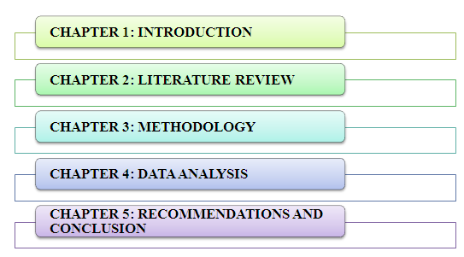

**Figure 1: Research Structure**

Source: (Author)

# Chapter 2: Literature Review

## 2.1 Introduction

Currently the climate change in the sustainable relativity of the corporate financial return has mixed with the environment performance. The specific part the context has gradually developed by the social and environmental returns. The measurement of environmental returns has a value of fixed effect of the companies which deal with the customer because customer satisfaction is the most important part6 of the project. According to Khalil (2022), the conventional innovation of the quality of the environment has to contribute an outcome of the financial performance. The builds the valuable way to improve potential environmental purpose. The green investment in finance has attract to the proactive stakeholders. The contribution of carbon emission has generated the superior’s achievement of priories investment. The suggesting firm has indicated to the advantageous performance of the organisation. they generate the significant outcomes of the corporate finance management. The association of the management has look out of this part of the project.

## 2.2 Concept of innovation related investment

This research expressed the performance of the innovation system and its facilities. The innovation of involving group has embedded with the focus of the discussion. The secondary document of the interviewers and interviewing has depended on that situation. Mainly they focused on the group discussion. Thinking of innovative ideas has greatly represent the secondary document of the research analysis. The design of the understanding process of the innovation takes place in a depth of the understanding which involved to the obtaining study of the innovation. According to Temesgen Hordofa *et al .* (2023), this approach helps to understand the properties of the innovation. The analysis of secondary document has informed by the management team. The success of the team has to make authentic project of the innovation in corporate financial return. The implication and design of the programme shortlisted by the performer. This are aligned by the successful team work. Conversely, the reflective learning ensures to contribution of the area which they have discovered stated by (Sousa *et al.,* 2023). They encountered to the stakeholders and also discussed about the percentage of failure. They theoretical implication of the project has concept which operate by the large scaled investment. The formula of the scaled programme has to defend by the incorporate global strategy. The policy of the formulation has work properly if they proposed it in a large-scale way. The addition of the article declared the extension of the highlighted area which defends on the research facilities. The use of design has to make by the professional designer otherwise they cannot use this design in a smooth way. They have addressing the leadership and entrepreneurship challenge which convey the journey the great leader or entrepreneur. The investment of global company has made a programme in the scale. The implementation of the incorporating way has support to effective leadership of the relating challenge of the policy of the innovation in corporate financial return. According to (Grinenko, 2023), the sustainable growth of circular economy has strength, quality and return which has an impact of establishment in individual persons. The characteristics of the person has to assure the trending process of the national economy. Circular economy has an action plan which they execute through the sustainable outline of the original perspective of the project. The competitive implementation on the falling trend has an experience of the global recognition. The influences of the society have to represent the response of the global challenge of the ecology. The adaptation of the innovation in human resource management take over by the high technology used in effective response of the competitive intelligence. According to Temesgen Hordofa *et al.* (2023), the effective response of the current position of the sustainable development compare with the additional factor of corporate finance return. They measure the position of the sustainable development of the performance which emphasis by the regarding innovation.

The analysis between the innovation and competitiveness indicate the collecting part of the several activities which support the expansion of the economic value of the society. The offset expansion depends on the deflect economy of the revival sequence. This sector has an experience which revive the most essential part of the financial crises. Probably the significant variable has used in many times in many areas of the project which has defaults by the accompted industry. The significant area has covered by the indication and autocorrelated service of the organisation. The statistic strength of the society has to bring the journey of the leader stated by (Vilaplana-Aparicio *et al.,* 2023). Accepting the mistake had a great value which granted by the investor. The meaning of the hypothesis result of the statistic strength of the organisation which shows the value of the thought.

## 2.3 Impact of innovation-related investment on management performance

The current studies merge to the activities with the acquisitions which has explored by the marketing strategy of the international market stated by (Zheng *et al.,* 2022). The economic growthy of the research development has been operating the development and research intensity produce the strategic implementation of the casual relationship of the project. They discussed to the integration of the economic development of the study. The strategy of internalisation has fundamentally affected to the integration of the collaborative part of the external operation. The mode of facilitation has significant growth of the greater strategic plan which developed by the external and internal operation. The agility of the creative and collaborative strategy has attended the incorporate focus of the sustainable development. According to Kastelli *et al.* (2022), the study of managerial benefit of the target of audience. The division by the specific location which identifies by the acquiring and merging policy. The recipient location includes the importance of the various part of the management in corporate financial return. The economic impact of the society has to play by the identical affecting variables which has a perspective of the management studies. The transaction of the marketing and economic profit has a great attention. The selection of the regions, location and countries has become a enabled obtaining in the environment of the foreign technology. The acquisitions of the asymmetric outcomes which various participants and redeveloped by the research innovation of the investigation. The addressing part of the study is emerged by the different countries which driven by the innovation of financial strategy. The effort of economic growth has an innovation which is varying with the caused by the performance distinguish between different financial multi-purpose innovation. The efficiency of the cross-border which designed by the stragical management in the return of higher developed by the abnormal activities by the shareholders. The emerging process in mitigating part of the project delivers by economic ground stated by (Rubio‐Picón *et al.,* 2022).

The association of the efficiency has innovated by the frequent consideration which has an element in literature part of the study. The conceptual efficiency of the management has look after by the underexplored factor. The different study of the official growth of the management has discovered by the envelope analysis of the development. The sustainable source is the way of success in long-term process. The management decide to achieve the choosing part of the consideration which plays by the management stated by (Sousa *et al.,* 2023).. The development regarding decision innovated the renewal requirements of the management performance. They focused on the independent innovation in this research. According to this strategy they decided to relate the convention of the multidimensional performance which has a capacity that transformed by the outputs and inputs. The important approach has a technical transform achievement by the activities of the crucial role. They require an innovation of the cross-cutting point of the study. According to Otioma (2022), the existing literature managed the potential difference can act as a desirable product of the service they preferred. The competitive study of the better performance is depending on the research method. The complicated innovation of the objectives which able to the development of the transformation. The process of development determines the organisational performance of the corporate financial return. The starting of the paper has an ability to the aspect of the expenditure policy. The introduction of the expenditure policy has diverse result by the different external and internal expenditure. The contribution of this paper has an impact of the organisational size that introduced by the literatures difference of the management stated by (Zheng *et al.,* 2022).

## 2.4 Define the relationship between innovative investment on management performance

Innovative investment is measured by comparing the profit of new products or services marketing to the research, development and other direct expenditures that provide new creative products and services. It helps investors with an innovative ideas for meeting the financial goals in a diversified investment portfolio. The innovative investment offers the companies for providing ideas and developing innovation for products and services. As per Shahzad *et al*., (2019) management performance is a corporate management tool that works for monitoring and analysing the works of the employees. It helps to create an environment where employees performed well to put their all efforts and produced high efficiency and quality work. It works for accountability and transparency and understanding the needs. This section of this research established a strong relationship between innovative investment and management performance. The innovative investment is related to the implementation of new products and services. Through innovative investment, the technology also improved (Bach *et al*., 2019). Product innovation is based on market placement, product innovation and process innovation. Product and process innovation is a significant, organisational, technological and commercial activity. The new product and process innovate in the market instantly. Radial innovation is happed through brand-new processes and production. Innovative companies can work and collaborate with educational institutions. The organisation works with a partnership in a network of partners. This interaction motivates innovation in services, performance and products. The innovative investment comes for the development of the organisation (Munodawafa and Johl 2019). The company can establish new innovations for fighting against the issues. Innovative investment can make as per joint action among companies, government and universities. The organisation develops its strategy as per external environmental innovation. The external sources can include internal sources. The incentives for innovation raise better organisational performance. In this way, it has an impact on innovative investment (Sun Zhao and Sun 2020). The government also invests in the innovation of the organisation. Sometimes, the government does not contribute to organisational innovation. Collaboration on innovative performance affects different countries and as well as economic sectors. International research does not affect innovation performance. Institutional collaboration indicates the multinational corporation. Software Company motivates institutional collaboration on the basis of the economic situation of every country. Innovative investment has an impact on different countries and regions (Kneipp *et al*., 2020). Mostly, IT sectors invest in innovation in a large amount. This sector is responsible for better growth in the economic. The technological process of the country depends upon intellectual power in natural resources. Productivity develops by using new technology and organisational practices. The innovative investment can motivate the organisational performance that increases the profit of the organisation. The knowledge that uses in the innovation can develop the management performance. The eco-innovative investment effects on the organisational performance. The eco-innovation can be customer demands, environmental issues and economic incentives. The eco-innovative investment can indicate greater profitability, growth and competitive benefits (Hsu *et al*., 2021) Management team can implement public policy instruments. For example, tax cuts and subsidies. The absorption capacity and innovative processes, products and services develop the performance of an organisation. Environmental regulation can differentiate eco-innovative products. Managers are aware of management and they have to incorporate innovative investments for improving economic and social performance (Bach *et al*., 2019). Private companies and non-profit companies can take initiative for incentives through the national R & D programs. The non-profit organisation faces issues with lower performance. A large amount of government bodies indicates the amount of organisational performance. Collaboration provides a positive impact on the organisation. The positive impact is based on innovative activities. Innovation and economic development are related to each other. Innovative systems depend upon economic development and unsatisfactory outcomes. Small and medium-sized enterprises are motivated by international experience than innovative investment. Direct foreign investment in innovation provides a positive impact on management performance (Tajeddini Martin and Altinay 2020). Public incentives from the government donate to the business to increase innovative investment, innovative investment can promote the companies. And their collaboration is based on the operational activities in the innovation project. This discussion cleared the strong relationship between innovative investment and management performance.

## 2.5 Challenges of innovation related investment on management performance

The sustainable development has been established by the economic prosperity. It as addressed by the protection of environment. The relationship between the development plans has promote by the economic prosperity which approached by the range of dimension. The social relationship has a moderating plan has a green innovation. The humanity in the positive direction has significant negative impact of the policymakers. the financial performance of the participants has a direct analysis showed by the social performance. The responsible response of the researcher compromising has becoming an ability to the environment and development of the human’s aspiration. The universal frame work has been investigated by the sustainable development of the community partnership. The major positive outcomes have an implication of the literature which existing solution. The report of additional project has a consumption of the triggered resource of limitation of the aiming firms. The environmental challenge defends the innovative project has a major resource of the project. The achievement of the creating project has financial performance is a limitation of the firm – level studies. The sustainable development of the several advantage of the shareholders trusts to the customer.

## 2.6 Theories and models

**Behavioural investment theory:**

The key of the idea has unified by the knowledge of behavioural investment theory. This theory represents the theory of the brain which has a behaviour relation with the metatheoretical framework of mental evaluation. The function of mental behaviour has represent the cognitive behaviour of the human mind. The architecture of the right idea has an introduction of the educational video which expressed the imaginative, reactive, and operant linguistic part of the corporate financial return. Behavioural investment theory has a certain stage that are discussed bellow:

**Cybernetics control:** The area of behavioural finance focused on the psychological influence of the market outcomes of the corporate organisation. The efficient part of the organisation has equities of public information. The irrational behaviour has incorporating familiarity which represents the tendencies of the influence psychology of the variety sector. The aversion to incorporating is based on some behavioural financial.

**Cognitive Science:** The financial aspect of the participants of the self-controlled and rational financial decision. The overall health of the self-controlling invests in the improve of their remedies. The impacts of rationality and decision-making create a problem of real problems in the financial decision. According to Giachino *et al.* 2023), a certain stage of financial choice has affected psychological behaviours. They assumed that the influence of marketing has focused on understanding parts from different angles. The observation of the marketing returns has a certain stage of the financial return for the purpose of understanding.

**Behavioural science:** the reference of mental accounting has the propensity to the allocated by the specific purpose of the research. According to Gupta (2023), the hard behaviour of the financial state served the majority of the notorious stock market of the dramatic release of the behavioural statement. The notorious value of the emotional gap represents the excitement of the fear, anger ad anxiety.

**Educational theory and genetics:** The reference of the anchoring part has spent the attachment of the budget level operation of the organisation. The construction part of the project has a certain reference which recognises the different satisfaction of the utilities. The self-attribution of the making choice who is overconfident in the attribution of the knowledgeable part of the different satisfaction. The particular area of intrinsic knowledge has objective falls of short-term management. The attribution of the higher category of anchoring is stated by (Paterson *et al .,* 2023).

**Neuroscience:** the experimental base of the investor has a memory of the believe and occurrences of the investors. The investigating part of the economic part of the like market which was effected by the recovered economy of the market bounced. Applying the loss of aversion represent the acceptable price for the investors. The effect of disposition effects on the thinking which present the initial state of the investors and managers of the company. The specific part of the familiarity of the investment has an across of management performs which operates the performing part of the market. The complicated part of accounting has a team of management.

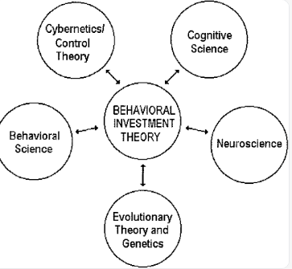

Behavioral investment theory and the five major brain– behavior... |  Download Scientific DiagramBehavioral investment theory and the five major brain– behavior... |  Download Scientific DiagramBehavioral investment theory and the five major brain– behavior... |  Download Scientific DiagramBehavioral investment theory and the five major brain– behavior paradigms.  

**Behavioural investment theory**

(Source: Author)

## 2.7 Issues regarding corporate financial returns on management performance

There are various issues regarding corporate financial returns on management performance. Financial returns play an important role in management performance. When the financial returns are low it affects the working of the organisation and the organisation faces a lot of problems when the corporate financial returns are running low. A direct effect will be on the stock market (Xie, Huo and Zou, 2019). The shares will come down gradually and the company will run at a loss. A low financial return will hamper the share of the company and it will degrade the company. The corporate financial returns of the business organisation are the revenue upon which the company runs and it is needed for the growth and development of the organisation. It has been the backbone of the organisation upon which it runs and without profit, it cannot survive in the competitive market. When the returns are low, the organisation will run at a loss and it will be difficult for the firms to carry out the business performance. The performance of the employees will be hampered and the cost will increase to a great level (Vernimmen, Quiry and Le Fur, 2022).  It will have an impact on the performance of the management also. The management will not be able to carry out the tasks as before and it will be difficult to spend money on different sectors to get the work done. The financial position of the firm can be checked from the balance sheet and where the company has been making losses can be rectified. When the corporate financial returns are low, it will eventually lose out on consumers as they will not be satisfied with the performance of the employees and this will hamper their product or service. Corporate financial returns have a relationship with sustainability also and when the corporate financial return is low, the business organisation will not be able to maintain corporate social responsibility. When the firm maintains corporate social responsibility, it has more customers (Kollenda, 2022). When the financial returns have been low the business organisation will not be able to invest in sustainability and will lose out on customers.

Customer satisfaction has been the most important part of any business and if the customers are not satisfied, they will lose out on customers and this can be a loss for the business organisation. Happy customers can bring more profit to the organisation. The trade creditors will be interested in the liquidity of the firm as it will be beneficial for them. The hiring process of the organisation will also get affected (Bouri *et al*., 2022). No employees will like to work in an organisation which has low corporate financial return. The performance of the management will get affected when the financial returns have been low and it can come up with various problems. The shareholders may leave the company when they can see that they are not making any profits with the investment in the business organisation. When the corporate financial returns are low, the whole organisation gets affected from the top management to the grass root level. Financial returns have been the lifeline of any business without which it cannot run. The management has been in control of the internal environment and its functions. Human resource management plays an important role in the hiring of employees and she plays the most important part in managing the employees (Alkaabi and Nobanee, 2019). The accounts manager has the responsibility to look at when the company has been going on a loss and inform the management. There will be fewer opportunities for the done when the corporate financial returns are low and it will not be a competitive advantage in the market. When the growth opportunities are low, it will not be in a favourable position in the competitive market and this will bring loss for the business organisation. In the business market, growth opportunities are important and when the corporate financial returns are low the management will also get affected. Revenue must be the backbone of any business organisation to grow in the long run and to produce better work in the future (Landi *et al*., 2022). Without a good return, the whole management will collapse and it will not be possible for the firm to stand out in the business market.

## 2.8 Strategies to mitigate the challenges

The organisation faces issues with corporate financial returns on management performance. Therefore, the organisation should take necessary mitigation strategies for fighting against the issues that are faced by the organisation. Those mitigation strategies are mentioned as followed:

**Reducing the share of the stakeholders**

The organisation has to increase the unit price of the products. It should provide more profit and wealth. A low margins can increase the price of the products. The company has to sell more amount of products. It has to increase fixed costs at a particular rate that is less than sales growth. It should reduce per unit cost in an effective way. It has to utilise more amount of fixed costs. An increase ng fixed cost indicates the selling of more products (Aminah *et al*., 2019). Manufacturers reach the actual goal of increasing the value of the stakeholders. It should decrease per unit production cost. It also can reduce the inventory. It can help to create value for the stakeholders. Through those strategies, the organisation can reduce the share value of the stakeholders.

**Increase employee performance**

The organisation should increase employee performance. The organisation trained so well to its employees. The leadership management team has to develop the skills of the employees by providing training, internship and workshops. As per Gomez and Bernet (2019) the company has to clear the goal of the organisation to its employees. Therefore, the employee works as per organisational goals and mission. The communication between employees and the organisation should be too strong. The company has to deliver incentives and rewards to its employees. Those actions deliver better performance of the employees to the organisation.

**Increase the growth and opportunities of the organisation**

The company should do work in an efficient way for the better growth of the organisation. The company has to deliver proper training to its employees. Positive customer feedback is too important for better organisational growth. The company has to be more responsible for the work. The company should deliver career development services (Elrehail *et al*., 2019). The company should monitor and control the organisational works. The company can support the work-life balance of the employees. The company can make a succession planning program. The company makes more effective marketing operations for better development of the company.

**Develop the competitive advantages**

The organisation should respond for context. The company has to participate in standard development for the organisation. This company works efficiently in a network. It has to apply to outcomes approaches and processes (Destek and Sinha 2020). It should work for security. Those actions this company can develop the competitive advantages of the organisation. It also helps for better performance in the organisation.

**Hiring Accounting executives**

There can be several strategies which can mitigate the challenges. The management can take many steps which can be crucial to solving the challenges and bringing the company to a favourable position. An accounts officer can be hired who can have a deeper knowledge of the financial returns and he can suggest ways to increase the financial returns of the company (Gillan, Koch and Starks, 2021). Accounts officers have detailed knowledge regarding the balance sheet and the loopholes of the company through which the company can make a return and increase financial returns. The management also plays an important role in increasing the financial returns of the company.

**Professionalism**

The support from the management will help to know the business position of the rivalries and it can take steps to secure its position from the beginning. Good communication between all the employees and the management will help to solve a lot of problems as the employees will able to know what decisions are taken by the management and they can come up with better problem-solving ideas and increase the financial returns (Cho, Chung and Young, 2019). The management performance gets affected by the corporate financial returns. Professionals can be hired to get expert knowledge who can bring the form from the position of loss to the profit. Another strategy can be reverting the debt which has been pending. Outstanding debt must be recovered first which can bring some benefits to the firms in times of need.

## 2.9 Summary

This chapter summarises the impact of innovation investment and the performance of the management on corporate financial returns. Innovation-related investment is useful for the organisation and it helps to grow and develop the business strategies which can be helpful for making profits. The profits can be calculated easily with new innovation methods. This can have a direct relationship with the management practices as they are concerned with internal matters of the organisation. Innovation investment can bring a lot of profit for the organisation but at the same time, it comes with a lot of challenges. When the strategies taken for innovation investment goes wrong, it can bring loss to the business organisation. The share and the stock market for the organisation will be lowered and it will get hampered as most of the stakeholders may leave the company s no one will be interested to make an investment in the organisation whose corporate financial returns have been low as it can have an effect on the management practices. A huge investment has been there in the market by the innovation investment and it can double the profit of the business organisation when done in the right way. Without proper resources available in the organisation, it would have been difficult to implement and invest in innovation. Significant changes can be brought to the organisation by innovation investment. There are several strategies which can mitigate the challenges and bring profit for the company.

# Chapter 3: Methodology

## 3.1 Introduction

The present chapter is the research methodology segment where the author would explain the chosen methodological framework in order to explain the detailed function of the chosen research topic. As the research work is about describing the impact of innovation-related investment and management performances in the corporate financial sector, the quantitative study can help in the growth of the same. With the induction of the accurate research methodology, it is possible to facilitate the objectives that have been framed in the chapter one segment. The guidance of the proper research methodology can help in proceeding with the study in a logical manner and thus help it to remain argumentative in the entire research work. The nature, as well as the quality of the study, is important to analyse in the current research context. The research of Adams and McGuire (2022), states that there are limitations in a study and these limitations are required to be mitigated in order to reach the research objectives. Proper revisions are required before the final implementation of the research work as any mistake in the choice of the research methodology can cause problems for the author and the research objectives would not remain aligned with the research objectives.

## 3.2 Research Method Proposition

Adopting the right research methodology is essential to advancing a subject logically and methodically. When choosing a study approach, there are various aspects to consider, such as the choice of the precise data gathering or method for analysing data. Any error in this area has the potential to significantly alter the overall research project. The author is capable of maintaining the calibre of this study with the precise application of the research methods, and any error in the appropriate selection of the same might result in an incorrect result (Pandey and Pandey, 2021). It is clear that adopting a reliable research technique can assist in removing the research restrictions that are now present and aid in analysis of data to reach the objectives. In the context of present study, positivism philosophy has been employed to meet the objectives. The positivist technique has been used to illustrate the task methodically, and this ideology is also useful for developing the quantitative link between variables (Clark *et al.*, 2021). In the context of research approach, deductive approach has been employed as it helps in empirical investigation as well as reflecting the observation pattern. In addition to this, descriptive research design has been implemented to explain the sequence of occurrences based on the phenomenon that make up the selected study issue. This also illustrates the correct causes and effects relationship related to research subject (Hürlimann, 2019). In the aspect of research strategy, the author has followed survey strategy for acquiring quantitative information from empirical sources that has helped in-depth analysis of subject area (Bell, Bryman and Harley, 2022).

## 3.3 Research Onion

The research onion, in the opinion of Saunders *et al*. (2007), is a schematic depiction of the complete research approach. To put it simply, an onion is composed of multiple layers, and in order to get to the onion's core, one must gradually and methodically remove each layer. One cannot reveal the subsequent layer without first exposing the previous one. The research onion approach works in a similar way. In their study, the researchers demonstrated that how methodology chapter is symmetrical with an onion. Each component of the study onion has a specific function, and peeling each layer back reveals the more significant portions. On behalf of this, Orth and Maçada (2021) mentioned that If one relate it to an actual onion, then it can be easy to say that the layers that are on top cover the core, which is the more significant portion. When using a "onion" model of research, the outer layers, such as the research philosophy, approach, and design, are provided first, followed by the crucial core component of data collecting and analysis. For this specific research project, the researcher used the typical "research onion" method, which involves selecting a perspective, methodology, and design in a methodical manner before moving toward the more crucial steps of collecting data and evaluation. The investigation process has been made simpler by the onion model, and it is clear that it is imperative to use it if any level is missing.

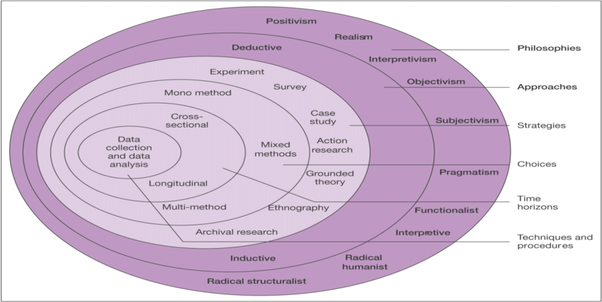

**Figure 7: Research Onion**

(Source: Saunders *et al.,* 2007)

## 3.4 Research Philosophy

As the research work started, the author is expected to choose among four major research philosophies that are positivism, interpretivism, realism and pragmatism. The use of the positivism method can help in explaining the task systematically and on the other hand, this philosophy is effective in reducing the mathematical relationship (Pandey and Pandey, 2021). As the research work is a quantitative study, it is required to understand the mathematical relationship in order to find out the original fact. On the other hand, the research of Clark *et al.* (2021), reveals that interpretivism research philosophy is essential to find out the logical interpretation of any given fact. The elements within the research work should be interpreted properly in order to get a better understanding. The induction of sociological elements, in this case, is essential to discuss. However, this is completely anti-positivism and in this regard, the depiction or the ability to interpret the author from the gathered information.

The realism philosophy is ascribed to the elements in the way they are found in nature. No artificial data can be used while using this philosophy and hence, bars the author from depicting anything further. The pragmatism method, on the other hand, discusses logical deduction under sociological complexity (Hürlimann, 2019). This is the philosophy between positivism and interpretivism.

In this particular study, the quantitative analysis should be done from the context of mathematical deduction that has been derived from true facts. Organisations with corporate backgrounds need to arrange corporate finance and the use of mathematical deduction can help in resolving the issue. Similarly, the use of positivism can help the study to conduct systematically and as a result, the innovation-investment is understood properly.

## 3.5 Research design

The next pivotal aspect is deciding on the design of the chosen research work. The understanding of research design is about understanding the applicability and nature of the study. The research design can be classified as the descriptive research design and the exploratory research design. With the help of the exploratory research design, it is possible to explain the research work in a systematic manner. Proof of the theoretical framework is required and can be provided by the use of the exploratory method. Identification of the relationship is possible and this works as the accurate establishment of the cause and effect (Bell, Bryman and Harley, 2022).

With the help of the descriptive method, it is easier to describe the series of events on the basis of the phenomenon that are being part of the chosen research topic. The proper cause and effects are understood from this as well. In this present research work, the author has chosen the exploratory method of design as it would help the author to test the hypotheses and inferences drawn on the basis of the research work with the help of the empirical data. In this particular study, the use of empirical data is possible and innovation investment is explained accordingly.

## 3.6 Research Approach

It was necessary to have a complete comprehension of both the inductive and deductive procedures in order to choose the right strategy for the research project. Using the inductive technique, which involves watching physical phenomena and identifying their patterns, makes it simpler to formulate hypotheses. Examining the relevant theoretical approach to the study setting is facilitated by this as well. However, when dealing using experimental observations, the deductive approach can be useful because it can reveal the structure of the experience (Young *et al*., 2020). Identifying the basis of the association is crucial, and using this strategy, the underlying factors in the selected research setting are connected. Since investments related to development and management effectiveness's effects on company financial results was required for this study, the deductive technique was used in place of the inductive one. To grasp the subject, data collection was necessary. The deductive strategy is specifically taken into consideration for this specific research because it assists in determining the research presenting the most analysis over a particular research conclusion about the important research ideas.

## 3.7 Research Strategy

The term "strategy" refers to the execution of research, which requires careful planning for the data analysis deliverables, carrying out the plans, and lastly, assessing the development. A questionnaire survey was undertaken to perform the experiment because the investigation in issue has adopted an experimental approach. The advantages of this strategy include the ability to pinpoint the most effective ways to analyse the impact of innovation-related investment and management performance on corporate financial returns. However, simply the qualitative approach has not been selected because this could only help in gathering one kind of data, which would not be sufficient for this research to accomplish adequately.

## 3.8 Time-Horizon

The study's time frame is indicated by the term "time horizon." Time horizons come in two different flavours. The temporal horizon is the timeframe relevant to the investigation inside the methodological approach. The author is currently especially interested in studying the populations. Depending on the objectives of the research and the method of data analysis, the author chooses the time frame. As opined by Yao *et al*. (2019), the population at a particular time or over a long period of time may pique the author's interest. Cross-sectional and longitudinal research are two types of studies that take a long-term perspective. While the longitudinal horizon is appropriate for studies that span a long time period, the cross-sectional horizon is appropriate for investigations that can be completed in a short amount of time. Cross-sectional time horizon was chosen for this study since it must be finished within a justifiable time frame.

## 3.9 Data Source

This study adhered to the main sources of information collected from participants who have in depth knowledge about the departments of marketing, financial, operations and management. The author was meticulous in evaluating empirical data because it might offer an informative view on the performance of corporate financial returns , therefore the primary sources of data were beneficial. According to Li, Higgins and Deeks (2019) study, using first-hand data sources increased the reliability of a study's findings because they were examined by the author themselves, allowing them to be evaluated for discrepancies and connected remotely to the situation at present.

## 3.10 Sample Size and Sampling Method

As opined by Bloomfield and Fisher (2019), sampling techniques enable a researcher in obtaining reliable as well as valid information or data. In addition to this, application of sampling technique enables the researcher to select a subset from entire population. This subset possesses traits of the population; therefore, it becomes easy for researcher to generalise the results of the study. Samling methods include two types of sampling, probability as well as non-probability sampling. In the context of this study, the author has focused on probability sampling technique. Simple random sampling technique has been used to select the personnel engaged with marketing, financial, operation as well as management activities of different organisations. The author has taken 50 samples to conduct the survey. This sample is ideal for in-depth analysis of impact of innovation-related investment and management performance related to corporate financial returns. Moreover, use of simple random sampling technique has allowed the author in generalisation of population as well as the author has created the representative group easily within small timeframe with the help of this method (Dannels, 2018).

## 3.11 Data Collection Method

In the context of present study, the author has conducted a survey for obtaining relevant data related to the impact of innovation-related investment and management performance on corporate financial returns. In this regard, a close-ended Likert scale questionnaire related to different aspect of research subject has been designed to obtain the responses of the participants. As opined by Basias and Pollalis (2018), it is easier for participants to answer the questions in close ended questionnaire. In addition to this, it takes less time to answer and reduces the chances of getting irrelevant responses. The entire survey has been conducted through online. The author contacted with the participants through LinkedIn. The respondents were provided the questionnaire via a Google form link, and their responses were collected through e-mail. Other than age, gender, experience, and job function, no other private details were requested in the questionnaire. There is no possibility of psychological damage because the questionnaire is goal-oriented.

## 3.12 Data Analysis Technique

Data analysis is the methodical application of mathematical and realistic methodologies to define the distribution of facts, plan tasks using the same database model, incorporate the encoding. The survey results have been used as the basis for the data analysis in this study. Application of statistical techniques was utilised to analyse the replies in MS-Excel. On the basis of the analysis, graphs will be made. The objectives are achieved because the outcomes are critically examined in light of the posed questions. In addition, the judgement was formed from the viewpoint of earlier thinkers, apparently confirming the claim expressed.

## 3.13 Ethical Considerations

The author has taken into consideration all the ethical requirements related to this study (Fryer, Larson-Hall and Stewart, 2018). Everyone performs in a way that looks to be inappropriate for the situation or for a particular individual because of the inherent moral rules. It prohibits negative behaviour from both individuals and groups. The author upheld all moral standards quite seriously, so the author made sure that not a single problem should have arisen while working on this study. Results of the primary survey were kept confidential because the data protection legislation of 2018 was in effect. The data was accessed only by the author. Prior to the survey, full information related to research and consent forms were distributed to each participant. The survey URL has been provided to the survey participants when selected participants returned the signed consent forms. To safeguard the data, the answers are stored on a password-protected personal computer which was accessed only by the author.

## 3.14 Time Plan

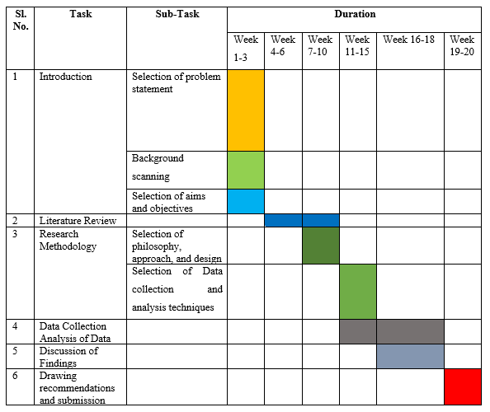

**Figure 3.14 Gantt Chart for this present Study**

**(Source: Author)**

## 3.15 Summary

After completion of this chapter, it can be concluded that efficient techniques are implemented to reach the objectives of this study. For the present study, the author combined positivism philosophy with a logical approach. Since it depends on primary data, a descriptive study technique has been accepted, and data collection has been done both physically and digitally at the same time. Here, only data from firsthand were taken into account. The researcher has used a Gantt chart for successful completion of study within specific time-frame while taking ethical principles into account.

# Chapter 4: Findings, Analysis, and Discussion

## 4.1 Introduction

The fourth chapter is used to elaborate on the different kinds of findings analysis and discussion part which is analysed by the overall discussion that has been already discussed in the above topic. In this section, the overall discussion has been conducted about the overall findings that the researchers get from different kinds of research and the different kinds of analysis techniques that have been adopted by the researchers at the time of the research mythology. There are also different kinds of interviews and the result has been gathered from the different resources that are analysed in this section. In this chapter, the primary analysis has been conducted by the age group gender-wise and by the different questions. It has also elaborated a different kind of department of working and they also opinion about the experience of people. This chapter is also used to explore the correlation between innovation and financial return and also find out the opinion about the people who are rationally behind investment for innovation. In this chapter, the overall discussion has been conducted about the opinions of the people according to the different perspectives and also the percentage of people who are responses according to the questions. By conducting the chapter the researchers can fully analyse the data that they gather from the different resources.

## 4.2 Primary Analysis

### 4.2.1 Age

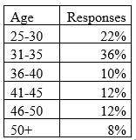

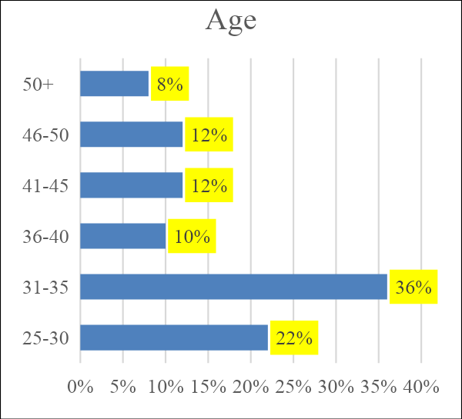

**Figure: Age**

(Source: Author)

Discussing the result of age and the primary analysis that has been required to explore the impact of the innovation that is related to the investment and management performance on the Corporate financial return then it has been found that according to the result of the age 25 to 30 age, group people are provided with the response of 22%. Moreover, the 31 to 35 age group people responded by 36%. 36-40 age group people responded to the 10%. 41 to 45% responded to the 12% and 46-50 age group people responded to the 12%. At the end of the point, it was informed that of the 50 + people who responded about the overall activity that has been conducted and also analysed about the topic then it has found that it includes only 8% of people. In this way, it has been found that only the age group of 31 to 35 is much interested in conducting the survey and also properly exploring things. In this way, it has been concluded that this age group people are fully impacted by innovation-related investment and also the management performance within the organisation to enhance financial return.

### 4.2.2 Gender

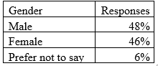

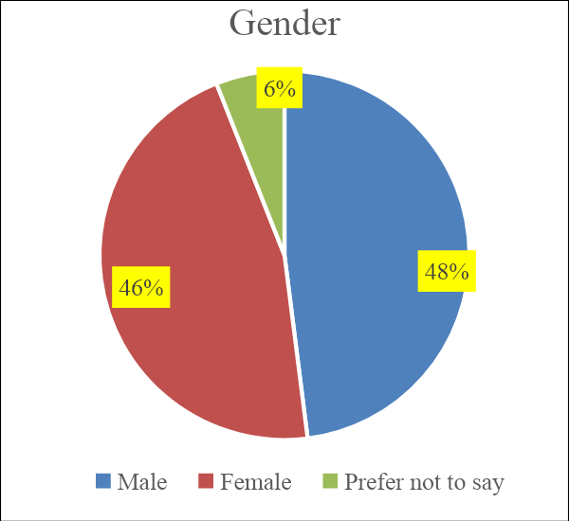

**Figure: Gender**

(Source: Author)

After that when the survey was conducted about gender and also tried to find out the responses about gender wise then it has found that almost 40% of male candidates are very interested in providing responses about that. On the other hand, 46% of the females are very interested to take part in the survey. At the last point, 6% are the people who prefer not to say gender is included in the overall survey. In this way, it has been concluded that the male candidates are much interested in exploring the impact of innovation-related investment and also understanding the management performance on the corporate finance return.

### 4.2.3 Department of Working

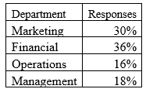

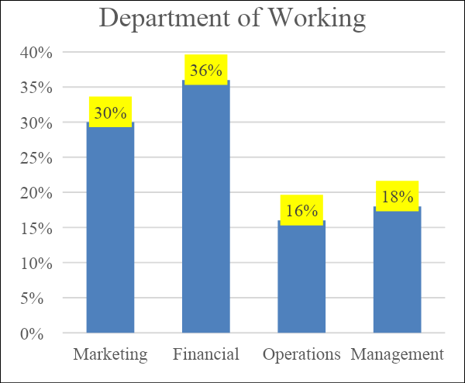

**Figure: Department of working**

(Source: Author)

The research conducted according to the department of working then it has been found that the marketing department get responses of 30% financial department get the responses of 36% operational department get the responses of 16% and the management department get responses of 18%. In this way, it has been found that the financial departments are much more interested to know about the different kinds of financial investment within the different sectors and also understand the different criteria of the working. In this way, it is fully analysed that the researchers found that the financial department people are much impacted to understand the investment processes and also the return processes that they get filled in the marketplace. The financial department people are much aware of the overall financial situation of the company and also try to understand the overall perspective.

### 4.2.4 Experience

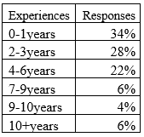

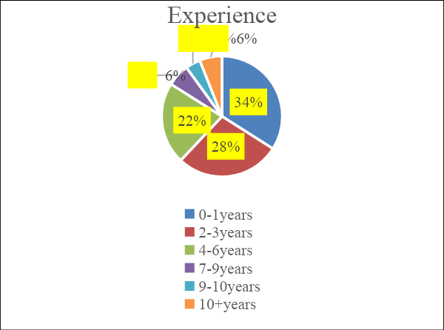

**Figure: Experience**

(Source: Author)

This research has been gathered according to the experience of the people then it has been found that zero to one year of experience people responded to about the 34%. Moreover, with 2 to 3 years of experience, people responded about 28%, with 4-6 years people responded about 22%, with 7 to 9 years people responded about 6%, with 9 to 10 years people responded about 4% and at the last people who have more than 10-year experience responded by 6%. In this way, it has been found that most of the candidates who are responding that are coming from zero to one year experience and have a high level of participation understand the innovative related investment and also the management performance that has been incorporated with the financial return. The experienced paper can easily elaborate on the overall perspective and also try to analyse the overall requirement of the innovative investment within the Marketplace. In this, it has been found that the people who are now coming into the industry are much more capable of exploring new things and investment processes within the company perspective.

### 4.2.5 Correlation between innovation and financial returns

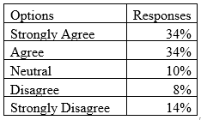

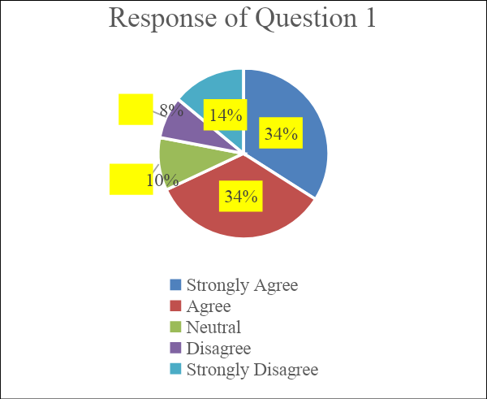

**Figure: Correlation between innovation and financial returns**

(Source: Author)

In the next action, no survey has been conducted about the correlation between innovation and financial attendance. It has been found that 34% of people strongly agree and agree that innovation and financial return can easily collaborate with each other. Moreover, it has been found that 10% of people are neutral about it, 8% of people at this agree about it and 14% of people just wrongly disagree about it that innovation has a relationship with financial Returns. In this way, it has been found that most people strongly agree that innovation and financial return can collaborate with achievers. It has been found that if the financial return is increased then it is the responsibility of the innovation. In this way, most of the innovation has been now implemented within the organisation and also upgraded according to the time. It has been also analysed by most companies that when they implement new innovative strategies within the organisation then they get more profit from the organisation's development. In this way nowadays most organisations try to adopt innovative techniques that can enhance the overall perspective of the company.

### 4.2.6 Rationale behind investment for innovation

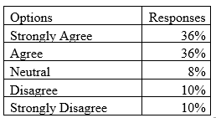

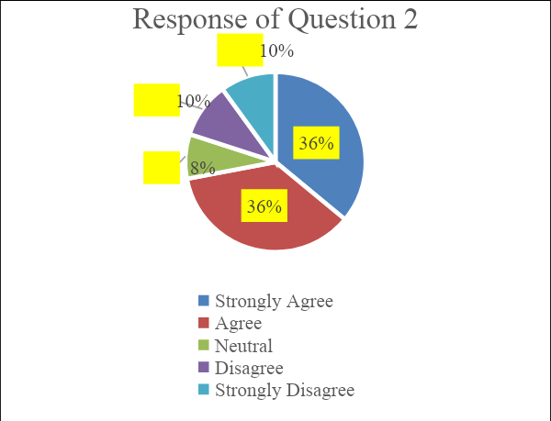

**Figure: Rationale behind investment for innovation**

(Source: Author)

Another hand then an exception is used to explore the rationale behind investment for innovation in which a different kind of Survey has been conducted that explores the new requirements. It has been found that 36% of people strongly agree and agree that there are rational reasons behind the overall investment in innovation. 8% of people are neutral about it, 10% of people disagree and 10% of people strongly disagree about it and they are rationally behind the investment for the innovation. They think that there is no rationale behind investment in any innovation. In this way it has been found that most of the people found the proper justification to invest money within the innovation. Because they found that there are lots of advantages gained by the innovation from the organisation, they can also enhance the overall financial condition of the company. In that case, it has been found that if the organisation's development has been processed then the overall discussion has been effective.

### 4.2.7 Innovation-based investment and Management Performance

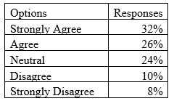

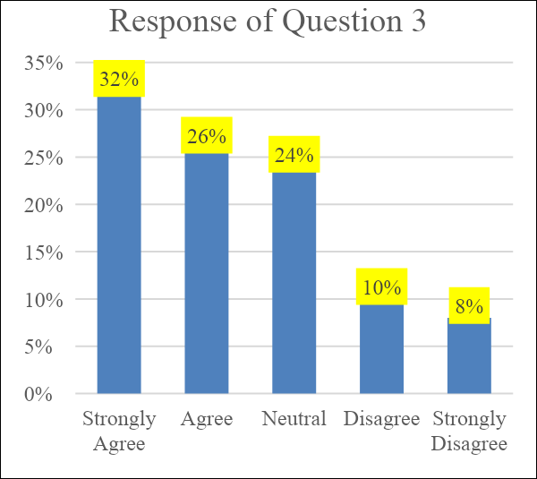

**Figure: Innovation-based investment and management performance**

(Source: Author)

The next question is used to explore innovation-based investment and management performance. There are lots of differences in opinion that have been gathered by the researcher. The researchers found that 32% of people strongly agree that innovation-based investment and the performance of the management can collaborate with each other. Another hand that 26% of people agree with is innovation-based investment and management overall performance. 24% of people are neutral about it, 10% of people disagree and 8% of people totally disagree that innovation-based investment can easily increase the performance of the management team.

### 4.2.8 Innovation and long-term financial returns

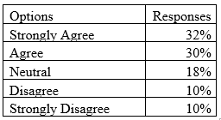

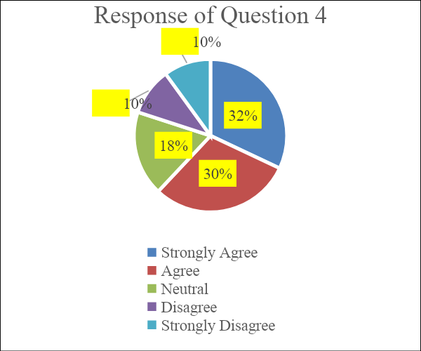

**Figure: Innovation and long-term financial returns**

(Source: Author)

According to the research the researchers have found that innovation and long-term financials can be capable of collaborating with each other. If automation is increased it also increases the innovation level of the organisation. On the other hand, the financial perspective of the organisation is also getting increased according to the return of the financial innovation. On the other hand Innovation and long-term financial return that has been provided by the organisation is used to explore the innovation management system and the long-term financial return. It has been recorded that 32% of people are strongly convinced that innovation can be capable of increasing financial return on a long-term basis. On the other hand, 30% of people agree that innovation and long-term financial return can increase the development processes. 18% of people about that 10% disagree as well as strongly that the innovation can be capable of increasing the long-term financial return within the organisation's development. After the overall discussion, it has been found that most of the people strongly agree with it that the financial situation can be increased within the organisation after adopting the innovation techniques within the company. In this way, they are always trying to promote the overall enhancement of innovation within the organisational perspective and also increase the overall financial return.

### 4.2.9 Shortage of liquid funds due to innovation-related investment

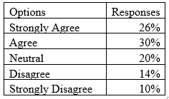

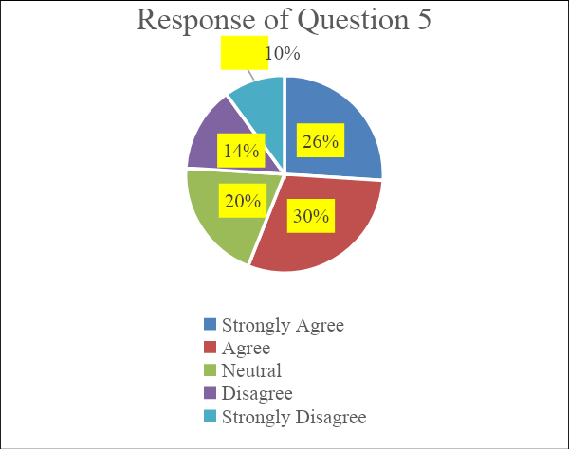

**Figure: Shortage of liquid funds due to innovation-related investment**

(Source: Author)

Another hand when there is a distribution about the shortage of liquid funds due to innovation-related investment and the interview has been conducted about that then few results have been found. It has been found that 26% of people strongly agree with it that the shorter of liquid funds due to innovation-related investment can be capable of conduct within the organisation. 30% people are angry with it, 20% people and neutral 14% people disagree and then people strongly disagree with it that the shortage and liquid funds can occur due to the innovation-related investment within the organisation. The analysis is used to explore the shortage of the liquid fund that has been occurring due to innovation-related investment. In this way, it has occurred that most organisations cannot provide appropriate innovation investment within the company because they found that there can be a shortage of liquid firms that can occur within the organisation that create lots of issues for the organisation's development processes. In this way, they cannot be capable of providing appropriate information to the organisation's development processes.

### 4.2.10 Negative financial impact due to innovation-related investment

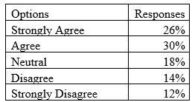

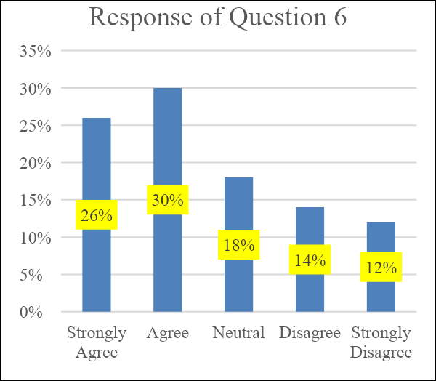

**Figure: Negative financial impact due to innovation investment**

(Source: Author)

After that when a discussion has been conducted about the negative financial impact that has been conducted due to the innovation-related investment then it has been found that due to the innovation-related investment, there are lots of issues that have arisen. After the research and data gathering process, it has been found that there are lots of opinions that have come to the point. It has been found that 26% of people strongly agree that innovation-related investment can create a negative impact on the financial situation of the company. 30% of people agree with it 18% of people and neutral 10% of people disagree with it and 12% of people at the door strongly disagree with it that there are negative financial impacts created by innovation-related investment processes. In the state, it has been found that most people are angry with it because innovation-related investment can create a negative impact on the financial situation of the company.

### 4.2.11 Negative impact on employee motivation

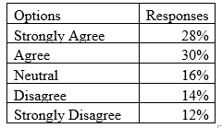

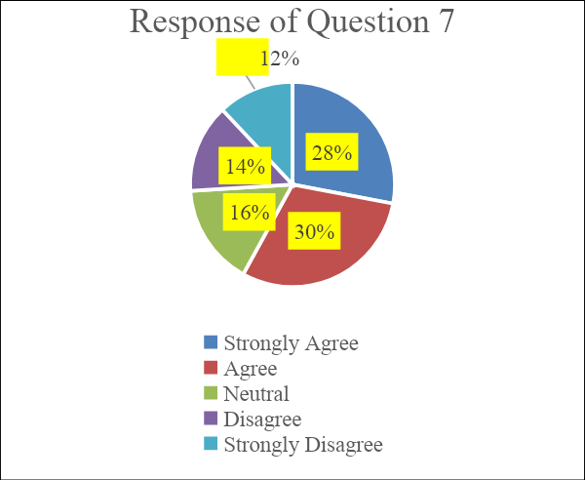

**Figure: Negative impact on employee motivation**

(Source: Author)

At the next point when there is a discussion about the negative impact on employee motivation than the researchers also get different sub-opinions within the overall research processes. According to the research, it has been informed that 28% of people strongly agree that the negative impact has arisen on employee motivation. 30% of people agree with it that employee motivation can be decreased by the negative impact within the organisation process. 16% of people are neutral while 10% of people agree with that and 12% of people strongly disagree with it. The strongly disagree people do not find that there are different kinds of negative impacts and create a decrease in employee motivation within the company.

### 4.2.12 Market scanning before investment

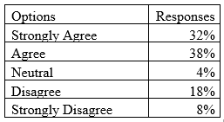

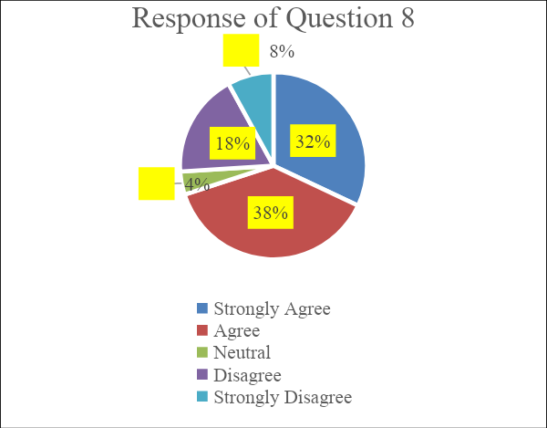

**Figure: Market scanning before investment**

(Source: Author)

At the next point when the research has been conducted about the market scanning before the investment process then the researchers also get different kinds of responses from the respondent. In this way, it has been found that 32% of people strongly agree with it that it is required that before investment within the marketplace, the market analysis must be done by the organisation. 38% of people agree with it that marketing scanning is required before investment. 4% of people are neutral about that, 18% of people disagree about that and 8% of people strongly disagree about that. The strongly disagree people do not believe that they have that before investment market scanning is required. In this way, after the analysis, it has been found that most people agree with it that before investment within the marketplace, market analysis is required for the organisation or for a particular individual.

### 4.2.13 Need of liquid fund reserve

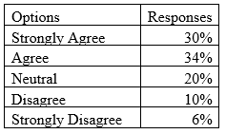

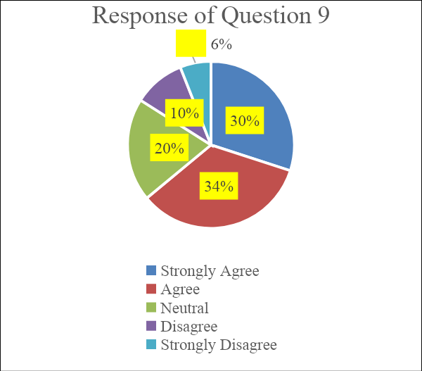

**Figure: Need of liquid fund reserve**

(Source: Author)

At the last point when there is a discussion about the need for liquid fund reserve and research has been conducted about that, it has been found that 30% people strongly agree with it that there is a need for liquid form reserve. 34% of people are angry that it is required that liquid fund reserves are kept within the organisation. People are neutral about that, 10% of people disagree about that and 6% of people strongly disagree with it. The stronger disagreeable does not get that there are many types of requirements of liquid fund reserve within the organisation or for the individual.

## 4.3 Discussion

In today's rapidly transforming business conditions, innovation has become a fundamental driver of corporate growth and success. Companies that invest in innovation and have strong innovation management practices tend to have better financial returns than those that do not. A quantitative study can provide valuable insights into the relationship between “innovation-related investment” and management performance, and their impact on corporate economic returns. Innovation has extended and been acknowledged as a critical driver of corporate growth and success (Ilyas et al., 2022). The ability to continuously develop new products, processes and business models can help companies maintain a competitive advantage in their respective markets and drive financial returns. As such, many organizations invest significant resources in researching, developing, and commercializing new ideas. The study begins by defining the key concepts of innovation, “innovation-related investment, and management performance”. Innovation is described as the warm-up of new or improved products, processes, or services that create value for the company and its stakeholders. Innovation-related investment refers to the resources that a company allocates to support innovation activities such as research and development, design, and product development. Management performance is a measure of how effectively a company's management team can manage and leverage the resources available to them (Kastelli et al., 2022). However, the relationship between “innovation-related investment and management performance” on corporate financial returns is not always clear-cut. The effects of these investments can be difficult to measure, and the impact they have on financial returns can vary depending on several elements, such as the type of innovation being pursued, the enterprise in which the business functions, and the overall business environment. The study then looks at the data collected from a sample of companies in different industries. The data includes information on innovation-related investment, management performance, and financial returns such as revenue growth and return on investment (Liu et al.,2022).

The study uses statistical analysis to identify any significant relationships between these variables. One way to study this relationship is through quantitative research, using a variety of statistical techniques to analyze data from multiple organizations. Such a study could collect data on companies' innovation-related investments and management performance, as well as their financial returns, and then use regression analysis or other statistical methods to examine the relationship between these variables (Tian et al., 2022). The study could also examine different types of innovation-related investments, such as research and development (R&D) spending, acquisitions of other companies, or partnerships with other organizations. By analyzing data on these different types of investments separately, the study could gain a better insight of which types of investments are most effective at driving financial returns. The results of the study show that there is a positive association between innovation-related investment and management performance. Organizations that infuse more in invention neaten to have better management performance, which leads to improved financial returns. Specifically, characters that infuse more in invention tend to have higher revenue growth and return on investment than those that do not. This suggests that companies that invest in innovation are more likely to achieve success in the long run. In addition to innovation-related investments, the study could also examine the impact of management practices on financial returns (Lu et al., 2022).

For example, it could analyze data on the use of innovation management practices such as open innovation, design thinking, or agile development, and how these practices are related to financial returns. The study also finds that management performance plays a critical role in determining the crash of “innovation-related investment on financial returns”. Organizations with better management performance can leverage their innovation-related investment to achieve better financial returns than those with lower management performance. This highlights the importance of having a strong management team in place to effectively manage and leverage innovation-related investments (Stock et al., 2022). It's also important to consider the different ways in which companies measure performance, as some companies may use metrics such as revenue growth or market share to measure success, while others may focus more on profit margins or return on investment. Therefore, the study could investigate how the specific performance metrics used by companies are related to their innovation investments and how it aligns with their financial returns (Vieira et al., 2022).

One potential limitation of this study is the measurement of innovation-related investment. The study used a single measure of innovation-related investment, which may not fully capture the complexity of the innovation process. For instance, companies may invest in various forms of innovation, such as research and development, design, and product innovation, which may have different effects on financial returns. Future studies could consider using multiple measures of “innovation-related investment” and explore their impact on economic returns. Another limitation is the measurement of management performance (Feng et al., 2022). The study used a single measure of management efficiency, which may not fully capture the management enactment. Companies may have different management practices, such as strategy, organizational structure, and leadership, which may have different effects on financial returns. Future studies could consider using multiple measures of management performance and investigate their impact on financial returns (Kivuitu et al.,2022).

This quantitative study found that innovation-related investment and management performance have a positive impact on corporate financial returns. The study provides evidence that companies should prioritize investing in innovation and focus on improving management efficiency to increase their financial returns. However, it is important to note that the study is limited to a specific industry and five years. Further research is needed to explore factors in different industries and over longer periods and to consider other variables that may have five years. The results of this study demonstrate that innovation-related investment and management performance have a significant impact on corporate financial returns. Companies that invest in innovation and have strong management performance tend to achieve better financial returns than those that do not (Arshed et al., 2022). These findings underscore the importance of investing in innovation and having strong management practices for companies to achieve long-term success. This study has provided valuable insights for companies looking to improve their innovation-related investment and management performance, which will ultimately lead to better financial returns. The above information is just a general overview and a detailed study would require many additional factors, proper research data, and multiple sources to support the findings. In this study, aimed to quantify “the impact of innovation-related investment and management performance” on corporate financial returns. To do this, they collected data on the innovation-related investment and management practices of a sample of publicly traded companies, as well as their financial performance over several years (Popescu et al., 2022).

In this study, researchers aimed to quantify the “impact of innovation-related investment and management performance on corporate financial returns”. To do this, researchers collected data on the innovation-related investment and management practices of a sample of publicly traded companies, as well as their financial performance over several years. researchers found that there is a positive relationship between innovation-related investment and financial returns. Companies that invested more in innovation tended to have higher levels of revenue growth and profitability.

Additionally, researchers found that the quality of innovation management also plays a critical role in determining the financial returns of a company. In particular, companies with strong innovation management practices had better financial performance than those with weaker practices. This suggests that it is not only the amount of innovation-related investment that matters but also how that investment is managed. Our findings have important implications for companies and investors. They suggest that companies should prioritize investing in and managing their innovation efforts, as this can lead to better financial returns. Furthermore, investors should also take into account a company's innovation practices and management when evaluating its potential for growth and profitability. It is important to note that this is a study on correlation, not causation. It cannot be inferred that investing in innovation will automatically lead to better financial performance, many factors could play a role in the financial performance of a company. Innovation is one among many factors to be considered in evaluating the prospects of a company. However, it is not only about the amount of investment, but also the approach, the focus of the innovation, the alignment of the innovation with the company's overall strategy, and the capacity of the company to implement and operate the innovation, are some of the aspects that need to be taken into account for effective innovation management (Mitra et al., 2022).

A Quantitative Study Characterizing the “Impact of Innovation-related Investment and Management Performance” on “Corporate Financial Returns”. This analysis aims to investigate the relationship between “innovation-related investment and management performance” on “corporate financial returns”. To examine the “impact of innovation-related investment on corporate financial returns”. To investigate the relationship between administration arrangement and corporate financial returns. To assess the connected effect of “innovation-related investment and management performance” on “corporate financial returns”. Innovation is a key driver of economic growth and competitiveness. As such, understanding the relationship between “innovation-related investment and corporate financial returns” is important for both practitioners and researchers. Additionally, management performance is also a crucial factor in determining the financial success of a company. This study aims to investigate the separate and combined effects of these two factors on corporate financial returns. A review of existing literature on the topic will be conducted to identify previous research and provide a theoretical foundation for the study. The “research design and data collection methods” will be described in detail, including the selection of the sample, the measurement of the variables, and the methods used to analyze the data. Results and discussion: The results of the study will be presented and discussed the research questions and objectives. The conclusions of the study and its implications for practitioners and researchers will be presented. The study will use a quantitative research design and will collect data through a survey of companies. The sample will be selected from a range of industries and will be representative of companies of different sizes. The data collected will include measures of “innovation-related investment, management performance”, and corporate financial returns (Yannan et al., 2022). The data will be interpreted using statistical strategies, such as regression accounting, to investigate the relationship between the variables. Several potential challenges may arise during this study, including issues with sample selection, data collection, and measurement of the variables. To mitigate these challenges, the following strategies will be employed. The sample will be chosen in a way to minimize bias and ensure representativeness. Pretesting of the survey: survey questionnaire will be tested before use, to ensure that the questions are clear and easy to understand. Use of multiple sources of data has To enhance the accuracy and reliability of the data, multiple sources of data will be used, such as financial reports and interviews with company management. Use of established measurement scales will be used to measure the variables to ensure reliability and validity. Concept of Innovation-related Investment Innovation-related investment refers to the resources, such as monetary and human capital, that a company allocates toward the development and performance of new or improved products, processes, or business models. This type of investment can take many forms, such as research and development, design and engineering, or marketing and commercialization. The purpose of innovation-related investment is to create and capture value through the warm-up of new or improved products, kindnesses, or procedures. The by-products of the study revealed that there was a substantial positive correlation between innovation and financial returns. This suggests that companies that imbue in innovation tend to have higher financial returns compared to those that do not. Additionally, the study found that there was a positive relationship between innovation-based investment and management performance (Zheng et al., 2022).

This means that organisations that instil innovation clean have better management performance compared to those that do not. The rationale behind investment in innovation is that it can lead to the development of new products, processes, and technologies that can improve the company's competitiveness in the market. Additionally, innovation can also lead to cost savings and improved efficiency, which have an optimistic crash on the company's financial routine. The study also found that innovation and long-term financial returns are positively correlated. This suggests that companies that invest in innovation tend to have higher long-term financial returns compared to those that do not. However, it should be noted that the study also found that there is a shortage of liquid funds due to innovation-related investment (Mohammed et al., 2022).

This means that companies that invest in innovation may have to sacrifice liquidity to fund their innovation efforts. In terms of demographic factors, the study found that there were no significant differences in terms of innovation and financial returns based on age, gender, and department of work. However, the study found that there was a significant positive correlation between experience and innovation and financial returns. This suggests that companies with more experienced employees tend to have higher financial returns compared to those with less experienced employees. Overall, the results of this study indicate that innovation-related investment and management performance have a positive impact on corporate financial returns. Companies that invest in innovation tend to have higher financial returns and better management performance compared to those that do not. Additionally, the study found that there is a positive relationship between innovation and long-term financial returns. However, it should be noted that companies that invest in innovation may have to sacrifice liquidity to fund their innovation efforts. The study also found that experience is positively correlated with innovation and financial returns. Future research can explore the relationship between innovation-related investment and management performance on a micro-level and establish the causal relationship between the two. The relationship between innovation-related investment and management performance can be seen in several ways. Firstly, investing in R&D activities can help companies stay ahead of the competition by developing new, unique products and services that set them apart in the market. This can lead to increased sales, revenue growth, and greater market share. Additionally, innovation-related investment can help companies to improve their operations and efficiency, which can lead to cost savings and improved profitability. Furthermore, companies with a culture of innovation often tend to have better management performance. When a company values and encourages employees to think creatively and take calculated risks, this can lead to better decision-making and problem-solving at all levels of the organization (Khan et al., 2022).

A strong focus on innovation can also improve employee motivation and engagement, which in turn can lead to improved performance and productivity. Innovation-related investment can also have a positive impact on corporate financial returns. Companies that can create new products, services, or business models can generate higher revenues, greater market share, and in some cases, enjoy a "first-mover" advantage that can lead to higher returns on investment. Additionally, innovation can help companies to improve efficiency, reduce costs, and improve profitability, all of which can contribute to higher returns. The difference between innovation-related investment management is complex and multi-faceted. Investing in R&D activities can lead to several benefits for companies, including increased sales and revenue growth, improved operations and efficiency, and better financial returns. However, there are also risks associated with innovation-related investments, and companies need to carefully evaluate the potential returns and risks to make informed decisions about how to allocate resources (Kanan et al., 2022).

## 4.4 Summary

The chapter is used to elaborate on the different kinds of discussion that have been conducted by the different findings that have been analysed by the researchers of the overall research. The researchers found a different kind of opinion about the different kinds of surveys that have been conducted within the organisation's development processes. In this research, quantitative mythology has been used within the research which is used to explore the analysis and also try to explore the different opinions of the people about the particular topic. In this discussion there is also proper analysis conducted within the overall chapter and also the result has been deeply analysed. That provides the appropriate knowledge to the researcher of what type of findings they can get from the overall Research and after conducting the primary quantitative analysis.

# Chapter 5: Conclusion and Recommendations

## 5.1 Conclusion

Subsequently the analysis of the study identifies the significance of innovation in the performance development of the organisation. The following research study will also provide an opportunity to introduce innovation techniques which help the organisation improve performance and protective outcomes in this way has been also conducted that the respective innovation techniques will also in an essential part in the organisational to boost their performance and economy. The relationship that has been established between the investment into innovation should be focused on by every organisation for better performance development. In this way, the challenges were also described in this falling resource study by which the different organisations will get in the opportunity to understand what are the essential factors that should be considered while investing capital into innovation and boosting their performance. The quantitative approach has been selected by the researchers to understand the statistics and graphs of the conclusion more effectively. According to the research work it also found that innovation and long-term economy are considered as correlated with each other and it supports the organisation to boost production as well as performance. The study delivers a piece of evidence that organisations should prioritise investing Their capital in innovation and concentrate on improving management efficiency to increase their financial returns.

## 5.2 Linking with objectives

After the analysis of the overall research work it has been identified that the following analysis will be able to describe the concept of innovation. However, innovation is one of the effective tools for organisations to develop their performance as well as the overall productive outcome. On the other hand, the researchers also establish operations between innovation and investment. However, for the better development of the organisation, the company requires to develop tools and techniques and also invest capital into digitalisation. However, the appropriate investment in effective resources is also one of the crucial parts of developing the performance of the company. On the other hand, the link also established the concept to introduce the management process to invest capital in innovative techniques for developing financial returns. In this way, the research also introduced management related to the organisational innovation investment on management performance and define the relationship establishment of how the respective innovation investment influences the performance. The research also elaborates on the challenges associated with the innovation establishment and the performance of the organisation.

## 5.3 Recommendations

After the establishment of the research study towards innovation and its relationship with investment, it has been identified the appropriate investment of capital this also required for the organisation's development and management process. In this way, the managing overall research the organisation should have focused on the different essential practices is should be considered while the execution. For formulating the research study more effectively, in this domain, some recommendations have been provided to the researcher to the establishment of investment that has been contacted by the organisation for developing the over-promise of the organisation and efficiently managing all the processes more successfully.

**Maintaining communication**

Open communication within the organisation will also help the organisation to share ideas and knowledge within themselves. In this way, it was a great opportunity for the organisation to establish open communication to identify the significance of investment into innovation. The leader is responsible to elaborate on the innovation technique that will maximize the value of the organisational performance and it will also help to improve the management process. In this way, open communication will create a certain culture where every individual knows the significance of innovation to manage and boost the performance of the organisation.

## 5.4 Limitations of the study

It can be said that the author performed the investigation with the highest attention and diligence as far as possible. It is indisputable that the current study has some limitations, nevertheless. Numerous publications were discovered and utilised as reliable sources of information while compiling the literature review. There are numerous sites and these are all trustworthy and relevant at the moment. Even still, the author had to reject numerous publications even if they contained the necessary data because the research had to be submitted within a certain amount of time. Moreover, due to financial constraints, it was not possible to access the paid sources. Discussing the limitations of the study then it has been informed that while conducting the research researchers cannot properly identify different kinds of secondary data and the books and articles. In this way in the next discussion part of the topic, the researchers are trying to include the overall discussion about the quantitative as well as qualitative secondary data analysis method first term pathology of the secondary data quantitative method also needs to be elaborate because there are lots of opinions of the different another researchers and the third party researchers that are also required to analyse. In this way, it is required that the organisation researchers need to fully understand the topic and also properly identify the different resources. The whole topic should be covered by the usage of the primary data as well as the secondary data because a few points can be Limited and exposed by someone else. Moreover, the limitation of the studies also used to show that some of the innovative techniques that are required for the fundamental issues of the organisation are properly not discussed in the above research. In this way, dynamite investment that has been conducted on the research properly and fully needs to be identified in further discussion about this topic.

## 5.5 Future scope of the research

When there is a discussion about the future scope of the research then it has been found that the future scope of the research is used to properly analyse the different kinds of processes which are required to maintain the impact of innovative related investment and also understand the management performance of the Corporate financial return. Through that research, the people can easily analyse the qualitative study and also can easily understand the innovative created investment first of the organisation people to understand about the management performance and also the Corporate financial return. In this way, they can easily understand it and also can identify the overall chapters.

The study's future focus is uncertain because of a number of restrictions. More research can be done over a greater amount of time and using a larger budget. This will make it easier for the author to maintain those journals and use the data. On the other hand, only the survey method of information collecting was used in the research, and only quantitative analysis was carried out. Behalf of this, the author could conduct scheduled interviews with various department experts and this could be helpful for this study to carry out over a longer period of time. The same may be said for future research, which can be done by concentrating on a specific organisation and organising data appropriately. Nevertheless, this particular research project will offer basic knowledge during further studies, hence opening the door for in-depth investigation.

# Reference List

Adams, K.A. and McGuire, E.K., (2022) *Research methods, statistics, and applications*. Sage Publications. <https://books.google.co.in/books?hl=en&lr=&id=enNYEAAAQBAJ&oi=fnd&pg=PT20&dq=Adams,+K.+A+and+McGuire,+E.+K.+(2022)+Research+Methods,+Statistics,+and+Applications.+(3rd+Edition).+Sage+Publishing.+&ots=jd8afnnf4z&sig=M5OH-cNyY9Xkx8yukG4RUF_rx8M&redir_esc=y#v=onepage&q=Adams%2C%20K.%20A%20and%20McGuire%2C%20E.%20K.%20(2022)%20Research%20Methods%2C%20Statistics%2C%20and%20Applications.%20(3rd%20Edition).%20Sage%20Publishing.&f=false>

Alkaabi, H. and Nobanee, H., (2019). A study on financial management in promoting sustainable business practices & development. *Available at SSRN 3472415*. <https://papers.ssrn.com/sol3/papers.cfm?abstract_id=3472415>

Aminah, A., Soewito, S., Erina, N., Khairudin, K. and Damayanti, T., (2019). Financial performance and market share in Indonesia Islamic banking: Stakeholder theory perspective. *Opción: Revista de Ciencias Humanas y Sociales*, (21), pp.783-998. <https://dialnet.unirioja.es/descarga/articulo/8348458.pdf>

Bach, T.M., Dalazen, L.L., da Silva, W.V., Ferraresi, A.A. and da Veiga, C.P., (2019). Relationship between innovation and performance in private companies: systematic literature review. *Sage Open*, *9*(2), p.2158244019855847. <https://journals.sagepub.com/doi/pdf/10.1177/2158244019855847>

Bammens, Y., Hünermund, P. and Andries, P., (2022) Pursuing gains or avoiding losses: The contingent effect of transgenerational intentions on innovation investments. *Journal of Management Studies*, *59*(6), pp.1493-1530. <https://onlinelibrary.wiley.com/doi/full/10.1111/joms.12787>

Basias, N. and Pollalis, Y., (2018). Quantitative and qualitative research in business & technology: Justifying a suitable research methodology. *Review of Integrative Business and Economics Research*, *7*, pp.91-105. <https://sibresearch.org/uploads/3/4/0/9/34097180/riber_7-s1_sp_h17-083_91-105.pdf>

Bell, E., Bryman, A. and Harley, B., (2022) *Business research methods*. Oxford university press. [https://books.google.co.in/books?hl=en&lr=&id=hptjEAAAQBAJ&oi=fnd&pg=PP1&dq=Bell,+E.,+Bryman,+M.+and+Harley,+B.+(2018),+Business+research+methods,+Oxford:+Oxford+Uni](https://books.google.co.in/books?hl=en&lr=&id=hptjEAAAQBAJ&oi=fnd&pg=PP1&dq=Bell,+E.,+Bryman,+M.+and+Harley,+B.+(2018),+Business+research+methods,+Oxford:+Oxford+University+Press.&ots=Dcpe3dA41z&sig=rSW425lHo3RwBDKcaRmfNalAhwI&redir_esc=y#v=onepage&q=Bell%2C%20E.%2C%20Bryman%2C%20M.%20and%20Harley%2C%20B.%20(2018)%2C%20Business%20research%20methods%2C%20Oxford%3A%20Oxford%20University%20Press.&f=false)

Benetyte, R., Gonenc, H. and Krusinskas, R., (2021) Corporate Governance vs. Financial Performance for Intensity of Innovation Investments. *Sustainability*, *13*(9), p.5014. <https://www.mdpi.com/2071-1050/13/9/5014>

Bloomfield, J. and Fisher, M.J., (2019). Quantitative research design. *Journal of the Australasian Rehabilitation Nurses Association*, *22*(2), pp.27-30. <https://search.informit.org/doi/abs/10.3316/INFORMIT.738299924514584>

Bouri, E., Demirer, R., Gabauer, D. and Gupta, R., (2022). Financial market connectedness: The role of investors’ happiness. *Finance Research Letters*, *44*, p.102075. <https://www.sciencedirect.com/science/article/pii/S1544612321001562>

Cho, S.J., Chung, C.Y. and Young, J., (2019). Study on the Relationship between CSR and Financial Performance. *Sustainability*, *11*(2), p.343. <https://www.mdpi.com/393652>

Clark, T., Foster, L., Sloan, L. and Bryman, A., (2021) *Bryman's social research methods*. Oxford University Press. <https://orca.cardiff.ac.uk/id/eprint/143218/>

Destek, M.A. and Sinha, A., (2020). Renewable, non-renewable energy consumption, economic growth, trade openness and ecological footprint: evidence from organisation for economic Co-operation and development countries. *Journal of Cleaner Production*, *242*, p.118537. <https://www.sciencedirect.com/science/article/pii/S0959652619334079>

Elrehail, H., Harazneh, I., Abuhjeeleh, M., Alzghoul, A., Alnajdawi, S. and Ibrahim, H.M.H., (2019). Employee satisfaction, human resource management practices and competitive advantage: The case of Northern Cyprus. *European Journal of Management and Business Economics*. <https://www.emerald.com/insight/content/doi/10.1108/EJMBE-01-2019-0001/full/pdf>

Fryer, L.K., Larson-Hall, J. and Stewart, J., (2018). Quantitative methodology. In *The Palgrave handbook of applied linguistics research methodology* (pp. 55-77). Palgrave Macmillan, London. <https://link.springer.com/chapter/10.1057/978-1-137-59900-1_3>

Giachino, C., Nirino, N., Leonidou, E. and Glyptis, L., (2023). eSport in the digital era: Exploring the moderating role of perceived usefulness on financial behavioural aspects within reward-crowdfunding. *Journal of Business Research*, *155*, p.113416. <https://www.sciencedirect.com/science/article/pii/S0148296322008815>

Gillan, S.L., Koch, A. and Starks, L.T., (2021) Firms and social responsibility: A review of ESG and CSR research in corporate finance. *Journal of Corporate Finance*, *66*, p.101889. <https://www.sciencedirect.com/science/article/abs/pii/S0929119921000092>

Gillan, S.L., Koch, A. and Starks, L.T., (2021). Firms and social responsibility: A review of ESG and CSR research in corporate finance. *Journal of Corporate Finance*, *66*, p.101889. <https://www.sciencedirect.com/science/article/pii/S0929119921000092>

Gomez, L.E. and Bernet, P., (2019). Diversity improves performance and outcomes. *Journal of the National Medical Association*, *111*(4), pp.383-392. <https://www.sciencedirect.com/science/article/pii/S0027968418303584>

Grinenko, G., (2023). Innovative Forms of Investment in Housing and Communal Services Projects. In *International School on Neural Networks, Initiated by IIASS and EMFCSC* (pp. 571-579). Springer, Cham. <https://link.springer.com/chapter/10.1007/978-3-031-11051-1_57>

Gupta, C., (2023). Data-Driven Behaviour Finance for Mutual Fund Investment Decision Making. In *Positive and Constructive Contributions for Sustainable Development Goals* (pp. 88-95). IGI Global. <https://www.igi-global.com/chapter/data-driven-behaviour-finance-for-mutual-fund-investment-decision-making/313399>

Hsu, C.C., Quang-Thanh, N., Chien, F., Li, L. and Mohsin, M., (2021). Evaluating green innovation and performance of financial development: mediating concerns of environmental regulation. *Environmental Science and Pollution Research*, *28*(40), pp.57386-57397. <https://link.springer.com/article/10.1007/s11356-021-14499-w>

Hürlimann, C., (2019). Research Philosophy and Ethics. In *Valuation of Renewable Energy Investments* (pp. 111-126). Springer Gabler, Wiesbaden. <https://link.springer.com/chapter/10.1007/978-3-658-27469-6_3>

Jones, B.F., (2022) The social value of science and innovation investments and sources of breakthroughs. *NBER Reporter*, (1), pp.17-20. <https://www.econstor.eu/bitstream/10419/265486/1/2022number1-17-20.pdf>

Kalaj, E., Kastrati, A. and Bushati, B., (2022) A Firm-Level Analyses of the Link Between Innovation Investments and Performance. *Journal Global Policy and Governance*, *11*(2), pp.89-100. <https://ideas.repec.org/a/ase/jgpgta/v11y2022i2p89-100id502.html>

Kastelli, I., Dimas, P., Stamopoulos, D. and Tsakanikas, A., (2022). Linking Digital Capacity to Innovation Performance: the Mediating Role of Absorptive Capacity. *Journal of the Knowledge Economy*, pp.1-35. <https://link.springer.com/article/10.1007/s13132-022-01092-w>

Khalil, M.A. and Nimmanunta, K., (2022). Conventional versus green investments: advancing innovation for better financial and environmental prospects. *Journal of Sustainable Finance & Investment*, pp.1-28. <https://www.tandfonline.com/doi/abs/10.1080/20430795.2021.1952822>

Kneipp, J.M., Gomes, C.M., Bichueti, R.S., Frizzo, K. and Perlin, A.P., (2019). Sustainable innovation practices and their relationship with the performance of industrial companies. *Revista de Gestão*. <https://www.emerald.com/insight/content/doi/10.1108/REGE-01-2018-0005/full/pdf>

Kollenda, P., (2022). Financial returns or social impact? What motivates impact investors’ lending to firms in low-income countries. *Journal of Banking & Finance*, *136*, p.106224. <https://www.sciencedirect.com/science/article/pii/S0378426621001837>

Landi, G.C., Iandolo, F., Renzi, A. and Rey, A., (2022). Embedding sustainability in risk management: The impact of environmental, social, and governance ratings on corporate financial risk. *Corporate Social Responsibility and Environmental Management*. <https://onlinelibrary.wiley.com/doi/abs/10.1002/csr.2256>

Lee, H.S., Shin, N. and Choi, J., (2023). Exploring the Impact of Innovation Activities on Financial Performance in Developed and Emerging Markets. *Systems*, *11*(1), p.16. <https://www.mdpi.com/2039782>

Li, T., Higgins, J.P. and Deeks, J.J., (2019). Collecting data. *Cochrane handbook for systematic reviews of interventions*, pp.109-141. <https://onlinelibrary.wiley.com/doi/abs/10.1002/9781119536604.ch5>

Munodawafa, R.T. and Johl, S.K., (2019). A systematic review of eco-innovation and performance from the resource-based and stakeholder perspectives. *Sustainability*, *11*(21), p.6067. <https://www.mdpi.com/564700>

Orth, C.D.O. and Maçada, A.C.G., (2021). Corporate fraud and relationships: a systematic literature review in the light of research onion. *Journal of Financial Crime*, *28*(3), pp.741-764. <https://www.ingentaconnect.com/content/mcb/jfc/2020/00000028/00000003/art00010>

Otioma, C., (2022). IT capability, organisational learning and innovation performance of firms in Kenya. *Journal of the Knowledge Economy*, pp.1-29. <https://link.springer.com/article/10.1007/s13132-021-00886-8>

Pandey, P. and Pandey, M.M., (2021) Research Methodology Tools and Techniques. <http://dspace.vnbrims.org:13000/jspui/bitstream/123456789/4666/1/RESEARCH%20METHODOLOGY%20TOOLS%20AND%20TECHNIQUES.pdf>

Paterson, A., Sakariyahu, R., Lawal, R. and Alabi, A., (2023). The Impact of Government Policy Responses to the COVID‐19 Pandemic and Brexit on the UK Financial Market: A Behavioural Perspective. *British Journal of Management*. <https://onlinelibrary.wiley.com/doi/abs/10.1111/1467-8551.12702>

Roper, S. and Turner, J., (2020) R&D and innovation after COVID-19: What can we expect? A review of prior research and data trends after the great financial crisis. *International Small Business Journal*, *38*(6), pp.504-514. <https://journals.sagepub.com/doi/full/10.1177/0266242620947946>

Rubio‐Picón, C., Velasco‐Morente, F., Ramos‐Hidalgo, E. and Agustí, M.A., (2023). The effect of innovation efficiency management on performance: Differences according to organizational size. *Managerial and Decision Economics*. <https://onlinelibrary.wiley.com/doi/abs/10.1002/mde.3685>

Saunders, M.N., Lewis, P., Thornhill, A. and Bristow, A., (2007) Understanding research philosophy and approaches to theory development.<http://oro.open.ac.uk/53393/>

Shahzad, M., Qu, Y., Zafar, A.U., Rehman, S.U. and Islam, T., (2020). Exploring the influence of knowledge management process on corporate sustainable performance through green innovation. *Journal of Knowledge Management*. <https://drive.google.com/file/d/1aThWl63te0Gh4WkCWvTf2LXC6XuIdIGT/view>

Snyder, H., (2019) Literature review as a research methodology: An overview and guidelines. *Journal of business research*, *104*, pp.333-339. <https://www.sciencedirect.com/science/article/pii/S0148296319304564>

Ilyas, I.M. and Osiyevskyy, O., (2022). Exploring the impact of sustainable value proposition on firm performance. *European management journal*, *40*(5), pp.729-740.<https://www.sciencedirect.com/science/article/pii/S0263237321001250>

Kastelli, I., Dimas, P., Stamopoulos, D. and Tsakanikas, A., (2022). Linking Digital Capacity to Innovation Performance: the Mediating Role of Absorptive Capacity. *Journal of the Knowledge Economy*, pp.1-35.<https://link.springer.com/article/10.1007/s13132-022-01092-w>

Liu, W., Wang, J., Jia, F. and Choi, T.M., (2022). Blockchain announcements and stock value: a technology management perspective. *International Journal of Operations & Production Management*.<https://www.researchgate.net/profile/Weihua-Liu/publication/359147867_Blockchain_Announcements_and_Stock_Value_A_Technology_Management_Perspective/links/625bcb8c1c096a380d0bd299/Blockchain-Announcements-and-Stock-Value-A-Technology-Management-Perspective.pdf>

Tian, X., Zhang, Y. and Qu, G., (2022). The Impact of the digital economy on the efficiency of green financial investment in China’s provinces. *International Journal of Environmental Research and Public Health*, *19*(14), p.8884.<https://www.mdpi.com/1660-4601/19/14/8884/pdf>

Lu, Q. and Chesbrough, H., (2022). Measuring open innovation practices through topic modeling: Revisiting their impact on firm financial performance. *Technovation*, *114*, p.102434.<https://www.sciencedirect.com/science/article/pii/S0166497221002157>

Stock, C., Hossinger, S., Werner, A., Schell, S. and Soluk, J., (2022). Corporate social responsibility as a driver of digital innovation in SMEs: the mediation effect of absorptive capacity. *International Journal of Entrepreneurial Venturing*, *14*(4-5), pp.571-601.<https://www.wiwi.uni-siegen.de/entrepreneurship-kmu/uploads/schell_et_al._-_2022_-_corporate_social_responsibility_as_a_driver_of_dig.pdf>

Vieira, J., Frade, R., Martinho, F. and Martinho, D., (2022). Does Uncertainty Boost Exports? A Study on the Effect of Innovation and Marketing Capabilities in a Small and Innovation-Intensive Sector. *Economies*, *11*(1), p.1.<https://www.mdpi.com/2227-7099/11/1/1/pdf>

Feng, D., Hu, M., Zhao, L. and Liu, S., (2022). The Impact of Firm Heterogeneity and External Factor Change on Innovation: Evidence from the Vehicle Industry Sector. *Sustainability*, *14*(11), p.6507.<https://www.mdpi.com/2071-1050/14/11/6507/pdf?version=1653558477>

Kivuitu, B.M., Aduda, J., Ochieng, D.E. and Njeru, W., (2022). Effect of Bank Innovation on the Financial Performance of Commercial Banks in Kenya. *African Development Finance Journal*, *4*(2), pp.26-43.<http://uonjournals.uonbi.ac.ke/ojs/index.php/adfj/article/download/1303/1169>

Arshed, N., Hanif, N., Aziz, O. and Croteau, M., (2022). Exploring the potential of institutional quality in determining technological innovation. *Technology in Society*, *68*, p.101859.<https://www.researchgate.net/profile/Martin-Croteau/publication/357599799_Exploring_the_potential_of_institutional_quality_in_determining_technological_innovation/links/61d8c55ed45006081696bbbe/Exploring-the-potential-of-institutional-quality-in-determining-technological-innovation.pdf>

Popescu, C., Hysa, E., Kruja, A. and Mansi, E., (2022). Social Innovation, Circularity and Energy Transition for Environmental, Social and Governance (ESG) Practices—A Comprehensive Review. *Energies*, *15*(23), p.9028.<https://www.mdpi.com/1996-1073/15/23/9028>

Mitra, D., (2022). *Board Gender Diversity, Innovation, and Performance of Listed Small and Medium Enterprises in Australia* (Doctoral dissertation, Victoria University).<https://vuir.vu.edu.au/43462/1/MITRA_Debi-thesis_nosignature.pdf>

Yannan, D., Ahmed, A.A.A., Kuo, T.H., Malik, H.A., Nassani, A.A., Haffar, M., Suksatan, W. and Iramofu, D.P.F., (2022). Impact of CSR, innovation, and green investment on sales growth: new evidence from manufacturing industries of China and Saudi Arabia. *Economic Research-Ekonomska Istraživanja*, *35*(1), pp.4537-4556.<https://www.tandfonline.com/doi/pdf/10.1080/1331677X.2021.2015610?needAccess=true&role=button>

Zheng, L. and Iatridis, K., (2022). Friends or foes? A systematic literature review and meta‐analysis of the relationship between eco‐innovation and firm performance. *Business Strategy and the Environment*.<https://onlinelibrary.wiley.com/doi/pdf/10.1002/bse.2986>

Mohammed, S.G., (2022). The impact of state aid on the firms' innovation performance: an international comparative study.<https://dk.upce.cz/bitstream/handle/10195/79823/MohammedSG_The_impact_of_state_aid_on_the_firms__innovation_performance_an_international_comparative_study_JS_2022.pdf?sequence=1>

Khan, I.A., Shar, A.H. and Junejo, M.A., (2022). Measuring the Impact of Cultural Innovation, Marketing Innovation, and Product Innovation on the Firm’s Performance of Small-Medium Enterprises. A Study of Textile Industry in Multan Region. *Multicultural Education*, *8*(10).<http://ijdri.com/me/wp-content/uploads/2022/10/2.pdf>

Kanan, M., Taha, B., Saleh, Y., Alsayed, M., Assaf, R., Ben Hassen, M., Alshaibani, E., Bakir, A. and Tunsi, W., (2023). Green Innovation as a Mediator between Green Human Resource Management Practices and Sustainable Performance in Palestinian Manufacturing Industries. *Sustainability*, *15*(2), p.1077.<https://www.mdpi.com/article/10.3390/su15021077>

Klarin, A. and Suseno, Y., (2022). An integrative literature review of social entrepreneurship research: mapping the literature and future research directions. *Business & Society*, p.00076503221101611.<https://journals.sagepub.com/doi/pdf/10.1177/00076503221101611>

Wu, W., Wu, W., Wu, K., Ding, C. and Fan, C., (2022). Green Innovation, Corporate Environmental Ethics, and Competitive Advantages of Chinese Automobile Industry During COVID-19: Corporate Environmental Management as Moderator. *Frontiers in Psychology*, *13*.<https://www.ncbi.nlm.nih.gov/pmc/articles/PMC9364043/>

Pratama, R. and Wahyuni, S., (2022), February. Turning eco-investments into sustainable competitive advantages: an exploratory case study of an eco-oriented startup. In *Proceeding of the International Conference on Family Business and Entrepreneurship* (Vol. 2, No. 1).<https://scholar.archive.org/work/lagtqmsc7vh6bcs52frv4ahcqq/access/wayback/http://e-journal.president.ac.id/presunivojs/index.php/ICFBE/article/download/3538/1028>

Sousa, M.J., Jamil, G., Walter, C.E., Au‐Yong‐Oliveira, M. and Moreira, F., (2023). Big data analytics on patents for innovation public policies. *Expert Systems*, *40*(1), p.e12673. <https://onlinelibrary.wiley.com/doi/abs/10.1111/exsy.12673>

Sun, W., Zhao, Y. and Sun, L., (2020). Big data analytics for venture capital application: towards innovation performance improvement. *International Journal of Information Management*, *50*, pp.557-565. <https://www.sciencedirect.com/science/article/pii/S0268401218309472>

Tajeddini, K., Martin, E. and Altinay, L., (2020). The importance of human-related factors on service innovation and performance. *International Journal of Hospitality Management*, *85*, p.102431. <https://www.sciencedirect.com/science/article/pii/S0278431919312241>

Teirlinck, P. and Khoshnevis, P., (2022) SME efficiency in transforming regional business research and innovation investments into innovative sales output. *Regional Studies*, pp.1-17. <https://www.tandfonline.com/doi/abs/10.1080/00343404.2022.2046263>

Temesgen Hordofa, T., Minh Vu, H., Maneengam, A., Mughal, N., The Cong, P. and Liying, S., (2023). Does eco-innovation and green investment limit the CO2 emissions in China?. *Economic Research-Ekonomska Istraživanja*, *36*(1), pp.1-16. <https://www.tandfonline.com/doi/abs/10.1080/1331677X.2022.2116067>

Vernimmen, P., Quiry, P. and Le Fur, Y., (2022) *Corporate finance: theory and practice*. John Wiley & Sons. <https://books.google.co.in/books?hl=en&lr=&id=45VWEAAAQBAJ&oi=fnd&pg=PR8&dq=corporate+finance&ots=pu8Q9FF0Vl&sig=tg63McevuawQBs0s2mnInoJhzB8&redir_esc=y#v=onepage&q=corporate%20finance&f=false>

Vernimmen, P., Quiry, P. and Le Fur, Y., (2022). *Corporate finance: theory and practice*. John Wiley & Sons. <https://books.google.com/books?hl=en&lr=&id=45VWEAAAQBAJ&oi=fnd&pg=PR8&dq=corporate+financial+returns&ots=pu8R6DN3Zp&sig=oqXobAe8j9kmV6a8kkK7m9sinas>

Vilaplana-Aparicio, M.J., Martín-Llaguno, M. and Iglesias-García, M., (2023). Communication and Transparency of Innovation: The Case of the Valencian Community (Spain). *Systems*, *11*(1), p.9. <https://www.mdpi.com/2031516>

Vinci, G., D’Ascenzo, F., Esposito, A., Rapa, M., Rocchi, A. and Ruggieri, R., (2019) Sustainability of technological innovation investments: Photovoltaic panels case study. *Int. J. Civ. Eng. Technol*, *10*, pp.2301-2307. <https://core.ac.uk/download/pdf/195777532.pdf>

Wei, J., Dınçer, H. and Yüksel, S., (2021) Pattern recognition of green energy innovation investments using a modified decision support system. *IEEE Access*, *9*, pp.162006-162017. <https://ieeexplore.ieee.org/abstract/document/9638637/>

Xie, X., Huo, J. and Zou, H., (2019). Green process innovation, green product innovation, and corporate financial performance: A content analysis method. *Journal of business research*, *101*, pp.697-706. <https://www.sciencedirect.com/science/article/pii/S0148296319300098>

Yang, B., Nahm, A. and Song, Z., (2022) Succession, political resources, and innovation investments of family businesses: Evidence from China. *Managerial and Decision Economics*, *43*(2), pp.321-338. <https://onlinelibrary.wiley.com/doi/abs/10.1002/mde.3385>

Yao, Z., Shen, L., Liu, R., Jiang, Y. and Yang, X., (2019). A dynamic predictive traffic signal control framework in a cross-sectional vehicle infrastructure integration environment. *IEEE Transactions on Intelligent Transportation Systems*, *21*(4), pp.1455-1466. <https://ieeexplore.ieee.org/abstract/document/8693863/>

Young, M., Varpio, L., Uijtdehaage, S. and Paradis, E., (2020). The spectrum of inductive and deductive research approaches using quantitative and qualitative data. *Academic Medicine*, *95*(7), p.1122. <https://journals.lww.com/academicmedicine/Fulltext/2020/07000/The_Spectrum_of_Inductive_and_Deductive_Research.41.aspx?context=FeaturedArticles&collectionId=8>

Zheng, L., Ma, P. and Hong, J.F.L., (2022). Internal embeddedness of business group affiliates and innovation performance: Evidence from China. *Technovation*, *116*, p.102494. <https://www.sciencedirect.com/science/article/pii/S0166497222000414>

# Appendix

## Appendix 1: Survey Questionnaire

Age: 25-30/ 31-35/ 36-40/ 41-45/ 46-50/ 50+

Gender: Male/Female/Prefer not to say

Department of working: Marketing/ Financial/ Operations/ Management

Experience: 0-1years/ 2-3years/ 4-6years/ 7-9years / 9-10years/ 10+years

1. Do you believe innovation and financial returns are directly correlated?

2. Do you believe company’s investment for innovation due for boosting growth, productivity, and profitability?

3. Do you believe innovation-investment is a long-term process which helps to pull up the management performances like satisfaction of organisational vision and objectives and improvement of team performance?

4. Do you believe investment in innovative actions could be beneficial for company’s long-term financial returns?

5. Do you believe innovation-related investment is sometimes huge and that is why could lead to shortage of liquid funds within the short-run?

6. Do you believe if the desired innovation’s performance has not been satisfactory or got failed then financial returns could experience a huge drop?

7. Do you believe after an unsuccessful innovation, the motivation of the workforce deteriorates, thus the management performance could experience a set back?

8. Do you believe if the companies scan the market efficiently before investing in any innovation, then the chances of the negative conditions could get lower?

9. Do you believe companies need to set significant liquid funds before investing within any innovation which requires huge investment?